
VILNIAUS UNIVERSITETAS
MATEMATIKOS IR INFORMATIKOS FAKULTETAS
PROGRAMŲ SISTEMŲ STUDIJŲ PROGRAMA

Laboratorinis darbas
Synq — System Requirements

and Technical Specification
Edvinas Bagdonas

Augustinas Bičkaitis

Arturas Kovtun
Martynas Masionis
Benas Stanulis

Darbo vadovas | : | Vasilij Savin

Table of Contents

Augustinas Bičkaitis 1
Arturas Kovtun 1
Table of Contents 2
SPECIFICATION SECTIONS 4
1. Introduction and Scope 4
1.1 System Overview and Business Problem 4
1.2 Target Users and Stakeholders 5
1.3 Scope, Assumptions and Exclusions 7
2. Business and Functional Requirements 9
2.1 User Roles and Permissions 10
2.2 Authentication, Users and Workspaces 10
2.3 Channels, Messaging and Message History 11
2.4 Presence, Search, Notifications and File Sharing 12
2.5 Shared Documents and Real-Time Collaborative Text Editing 13
2.6 MoSCoW Prioritization and Release Scope 15
3. Use Cases and Business Flows 15
3.1 Registration, Login and Workspace Invitation 16
3.2 Channel Message Delivery and Retrieval 18
3.3 Creating and Sharing a Collaborative Document 20
3.4 Simultaneous Editing, Conflict Handling and Synchronization 22
3.5 Disconnect, Reconnect and Service Failure Scenarios 23
4. Non-Functional Requirements 25
4.1 Performance, Capacity and Response-Time Targets 25
4.2 Availability, Reliability and Fault Tolerance 26
4.3 Security, Authorization, Privacy and Data Retention 26
4.4 Consistency, Message Ordering and Conflict Resolution 27
4.5 Usability, Accessibility and Observability 27
5. High-Level Architecture 28
5.1 System Context and Deployment Topology 28
5.2 Services, Modules and Package/Class Diagrams 28
5.3 Inter-Service Communication and Message Broker 30
5.4 Distributed Real-Time Messaging and Presence 30
5.5 Collaborative Editing Architecture (Yjs CRDT) 30
5.6 Data Ownership, Persistence and Replication 31
5.7 Horizontal Scaling, Failover and Recovery 31
6. API Contracts and Real-Time Protocols 32
7. Data Model 33
7.1 Users, Workspaces, Memberships and Roles 33
7.2 Channels, Messages, Threads and Reactions 35
7.3 Documents, Participants, Edit Operations and Versions 37
7.4 Files, Presence, Sessions and Notifications 38
7.5 Database Ownership, Indexes and Integrity Constraints 40
8. UI/UX Wireframes and Navigation 43
8.1 Screen Map and Navigation Flows 43
8.2 Authentication, Workspace and Channel Screens 43
8.3 Chat, Threads, Search and File Sharing Screens 44
8.4 Collaborative Editor and Active-Participant Indicators 44
8.5 Loading, Offline, Reconnection and Permission States 44

Implementation Note
Infrastructure technologies such as PostgreSQL, RabbitMQ and Redis are illustrative choices and may be replaced by equivalent solutions if all functional, non-functional and architectural requirements are met. Yjs Y.Text is an explicit mandatory V1 architectural choice under FR-030.

SPECIFICATION SECTIONS

1. Introduction and Scope
Synq is a greenfield, web-based team communication platform built as a distributed system of cooperating services. This section defines what Synq is, who it serves, what the first version will and will not do, and the vocabulary used in the rest of the specification.

1.1 System Overview and Business Problem
Synq lets teams talk and write together in one place: workspaces, public and private channels, direct messages, file sharing, and shared documents that several people edit at the same time inside a channel. It is inspired by Slack, Microsoft Teams and Discord, but Synq uses a distributed, service-based backend: independently running Messaging and Collaboration instances communicate using events and shared durable infrastructure. The V1 demo runs on one host, so the host and shared infrastructure remain potential single points of failure.
Business problem. Teams usually split their work across a chat tool, email attachments and a separate document editor. This causes three concrete problems:
- Context switching – discussion happens in chat, but the document being discussed lives somewhere else.
- Conflicting versions – documents passed around as files get overwritten or forked, and work is lost.
- Stale activity state – users cannot tell who is online, what they have not read yet, or who is editing right now.
Synq solves this by keeping conversation, files and live documents in the same channel, with presence and unread state kept in sync on every connected client.
Technical problem. Many users are connected at once, and every message, reaction or document edit must reach the right people in real time, in the right order, without being lost. A single central chat server would be both a bottleneck and a single point of failure. Therefore, Synq splits responsibilities into independent services that communicate asynchronously through a message broker, and runs real-time messaging and collaborative editing on several instances. The concurrent-editing problem (two users changing the same text at the same moment) is solved with a conflict-free synchronization approach.
Synq mapped to the Generic IT System Architecture

Architecture part | What it is in Synq
Input Command | User actions: sign in, create workspace or channel, send message, reply, react, upload file, open or edit a document, search
Input Data | Message text, document edits, uploaded files, profile fields, role and membership changes
Business Logic / Rules | Permission checks, channel membership, per-channel message ordering, edit conflict resolution, unread counting, notification rules
Data Store | Relational database (users, workspaces, channels, messages), in-memory store (presence, sessions), object storage (files), document state and edit history
Notifications | Real-time events pushed to connected clients: new messages, mentions, reactions, presence changes, document changes, unread updates
Output Data | Message history, search results, document content, file downloads, member lists
External Dependencies | Infrastructure only: message broker, database, in-memory store, object storage. No third-party business integrations in version 1

1.2 Target Users and Stakeholders
Synq targets small and medium teams (project teams, study groups, small companies) that need one shared place to communicate and co-write. Each workspace has exactly one Owner, zero or more Administrators, and regular Members. Roles are assigned separately in each workspace, so one person can hold different roles in different workspaces.
User roles
Role | Who they are | What they can do
Owner | The user who created the workspace (exactly one per workspace) | Everything an Administrator can do, plus assign or remove Administrators and transfer ownership. The Owner cannot be removed
Administrator | Members appointed by the Owner | Invite users, remove Members, create, rename and archive channels, add or remove private-channel participants, delete messages for moderation, rename or delete documents
Member | Regular participant | Join public channels, send messages, start direct and group conversations, reply, react, share files, create and edit documents in channels they can post to, search accessible content
Channels are managed at workspace level: only the Owner and Administrators create, rename and archive channels and add or remove private-channel participants. There are no channel-specific roles. Unauthorized users cannot view private content.
Stakeholders
Stakeholder | Interest in Synq
End users (Owners, Admins, Members) | Fast, reliable messaging; no lost edits; accurate presence and unread state; data kept private
Design team (authors of this specification) | A clear design with documented design decisions on scalability, consistency and fault tolerance
Implementation team (developers who build Synq from this specification) | Clear, concise and unambiguous requirements, interfaces and data models they can implement and test without guessing
System operator (whoever deploys and runs Synq) | Services that start, scale and restart independently, with logs and health checks to see failures

1.3 Scope, Assumptions and Exclusions
Version 1 defines a web client and independently running backend services across the ten capability areas below. The baseline V1 release requires only MUST functionality (Section 2.6); SHOULD functionality is optional and COULD items require separate agreement. Everything else explicitly excluded is out of scope so implementation can focus on the distributed core: real-time messaging, collaborative editing and fault handling.
In scope (version 1)
Area | Included | Responsible service (indicative)
Authentication and profiles | Registration and sign-in with email and password; server-validated sessions and sign-out; edit display name and profile image | Auth Service
Workspaces, channels, roles | Create multiple workspaces; email-bound invitation links valid for seven days; public and private channels; channel archiving; Owner/Administrator/Member roles and permission checks on every request | Workspace Service
Messaging | Real-time channel messages and one-to-one conversations (2 participants) and group conversations (3–20 participants); paged message history; deduplication and stable order per conversation | Messaging Service (2+ instances)
Message interactions | Thread replies, emoji reactions, message editing and deletion, moderation with an audit record (SHOULD) | Messaging Service
Shared documents | Named plain-text documents (up to 100,000 characters) inside a channel; simultaneous multi-user editing; see who is editing; durable document state; reconnection and resynchronization | Collaboration Service (2+ instances)
Search | Search over message text the user is allowed to see (SHOULD) | Search Service
Presence and unread state | Online/offline status across multiple sessions; per-conversation last-read position and unread counts | Presence Service (online status); Messaging Service (unread state)
Notifications | In-app notifications for direct messages and mentions (SHOULD) | Notification Service
Files | Upload and download of PNG, JPEG, PDF and TXT attachments up to 10 MiB, with access re-checked on every download; stored in object storage | File Service
Distribution and fault handling | Asynchronous events through a message broker; client reconnection and catch-up on missed events; service keeps working when one instance fails | All services
Priorities for each requirement (MUST, SHOULD, COULD, WON'T) are set in Section 2.6. The final service decomposition and the reasons behind it are defined in Section 5.
Assumptions
- Users access Synq from a current desktop version of Chrome, Firefox or Edge with a stable internet connection.
- The system is a greenfield project: no existing systems, data or APIs must be reused or migrated.
- Version 1 is sized for a demo load of up to 100 concurrently connected users and 50 workspaces; shared documents are tested with at least three simultaneous editors connected through at least two editing instances.
- All services run on one host with Docker Compose; “multi-node” means at least two running instances of the Messaging and Collaboration services, not separate physical machines.
- Attachments are PNG, JPEG, PDF or TXT files of at most 10 MiB; messages are at most 4,000 characters; documents are plain text of up to 100,000 Unicode characters.
- Message order is guaranteed within one conversation only, not globally across the system.
- Server clocks do not define ordering: chat uses per-conversation sequence numbers, while document edits converge through the chosen Yjs CRDT.
- Apply data minimization to account details, sessions, messages, shared documents, attachments and activity metadata. User-generated content may contain personal or sensitive data; protect it with access controls and do not include message/document contents in diagnostic logs (NFR-009).
- The user interface is in English only.
Out of scope (exclusions)
- Voice and video calls, screen sharing.
- Graphical canvas elements, whiteboards and advanced layout or design tools in shared documents (possible future extension).
- External public sharing of documents.
- Native mobile and desktop apps.
- Integration with external services: third-party apps, bots, webhooks and single sign-on with external providers.
- Email and mobile push notifications (notifications are in-app only).
- End-to-end encryption of messages.
- Billing, subscription plans and usage quotas.
- Shared channels between different workspaces and guest accounts.
- Multi-region deployment and automatic cloud autoscaling.
- Search inside file contents, fuzzy or semantic search.
- AI-assisted features.
Offline editing over longer periods and document revision history are optional (COULD) and are added only by explicit agreement.

2. Business and Functional Requirements
This section defines the first-release behavior of Synq, a web-based distributed team communication platform with integrated real-time collaborative text editing. It follows the scope, assumptions and exclusions set out in Section 1.3. Requirements marked MUST form the minimum implementable product; SHOULD items are optional enhancements, while COULD items require separate approval and are not included in the baseline first release.

2.1 User Roles and Permissions
An unauthenticated visitor can register or sign in, but cannot access workspaces. An authenticated user may belong to multiple workspaces. A workspace has exactly one Owner, zero or more Administrators, and regular Members. Roles are defined separately in each workspace. A user's effective permissions depend on both their workspace role and whether they may access the target channel.
Permissions by action (roles and conditions):
• Create workspace: authenticated user; creator becomes Owner.
• View workspace and its public-channel directory: Owner, Administrator, Member of that workspace.
• Invite users and remove Members: Owner or Administrator. Assign or remove Administrators and transfer ownership: Owner only; each workspace has exactly one Owner (initially its creator), who cannot be removed.
• Create or rename a public/private channel: Owner or Administrator.
• Archive channel: Owner or Administrator. Archived channels are read-only.
• Join a public channel: any workspace member. Read/send messages: channel participant, or workspace administrators/Owner where applicable.
• View/join a private channel: participants added by the Owner or an Administrator, plus the Owner and Administrators; private-channel content must not appear in unauthorized searches.
• Manage private-channel participants: Owner or Administrator.
• Edit/delete a message: its author; Administrator or Owner may delete other users' channel messages for moderation (SHOULD), but not messages in DIRECT or GROUP conversations.
• Create/edit a shared document: member with write access to its channel; delete or rename: document creator, Administrator or Owner.
• Access attachments and search results: only if the requesting user currently has permission to access their parent channel or conversation.
Permission checks must occur on every server-side request and real-time subscription, not only when showing or hiding UI controls. Revoking membership must prevent subsequent messages, file access and document edits, including through existing connections.

2.2 Authentication, Users and Workspaces
- FR-001 | MUST | Registration and login. Register and sign in with a unique (case-insensitive) email, display name and password of at least eight characters. Store only password hashes.
  - Acceptance: Duplicate emails fail; valid credentials work; invalid credentials produce a generic error.
- FR-002 | MUST | Authenticated sessions. Issue server-validated sessions and support sign-out. Expired or revoked sessions must lose API and real-time access.
  - Acceptance: Signed-out or expired sessions cannot call protected APIs or receive protected events.
- FR-003 | MUST | User profile. Allow users to edit their display name and profile image; account email remains unchanged in V1.
  - Acceptance: Profile changes become visible; invalid or oversized images are rejected.
- FR-004 | MUST | Workspace creation. Allow users to create multiple workspaces with 2–64-character names. Each workspace has separate members and channels; its creator is Owner.
  - Acceptance: Only joined users can access a workspace and its content.
- FR-005 | MUST | Workspace invitations. Owners and Administrators may generate seven-day, single-use invitation links bound to an email address; accepting a valid link adds the invitee as Member. Sending invitation emails is not required in V1.
  - Acceptance: Expired, reused and wrong-email invitations fail; valid invitations create one membership.
- FR-006 | MUST | Workspace role changes. Only the Owner may assign or remove Administrators; removals follow 2.1, while maintaining exactly one workspace Owner.
  - Acceptance: Unauthorized changes fail; removed users lose channel, message and document access.
- FR-007 | MUST | Leaving or removing a workspace. Members may leave; the Owner may remove Administrators and Members, and Administrators may remove Members. The Owner must transfer workspace ownership before leaving. Revoke all former access.
  - Acceptance: Removed users cannot access previous content, including via an existing connection.
- FR-008 | MUST | Workspace navigation. Show a user's joined workspaces, accessible channels and members, with workspace switching.
  - Acceptance: Switching workspaces does not expose unrelated data.

2.3 Channels, Messaging and Message History
- FR-009 | MUST | Channels. Allow the Owner and Administrators to create public/private channels with workspace-unique names (2–50 characters) and to rename or archive them; archived channels retain read-only history.
  - Acceptance: Duplicate names fail; archived channels reject new messages and edits.
- FR-010 | MUST | Private-channel access. Limit private channels to added participants, Administrators and the Owner; only the Owner and Administrators may add or remove participants.
  - Acceptance: Unauthorized users cannot discover, subscribe to or access private content.
- FR-011 | MUST | Sending a message. Authorized participants may send up to 4,000 characters of text, or an attachment-only message with no text. A message must contain text or at least one READY attachment, and may include no more than five READY attachments. Persist its ID, sender, conversation and timestamp.
  - Acceptance: Invalid text is rejected; accepted messages survive refresh and restart.
- FR-012 | MUST | Real-time delivery. Deliver accepted messages live to authorized participants across different messaging instances.
  - Acceptance: Clients on different nodes receive the same message; unauthorized clients do not.
- FR-013 | MUST | Message history and reconnect catch-up. Provide ordered, paginated conversation history and retrieve missed messages after reconnection, including via another node.
- Acceptance: Pagination and reconnection return persisted messages once, in conversation order.
- FR-014 | MUST | Message deduplication and ordering. Use a client-generated request ID to deduplicate message retries and maintain a stable order per conversation.
  - Acceptance: Retrying after a lost acknowledgement creates one message; clients agree on its order.
- FR-015 | MUST | Direct and group conversations. Support DIRECT conversations with exactly two participants and GROUP conversations with 3–20 participants from the same workspace.
  - Acceptance: Participants can exchange messages; excluded users cannot access conversations.
- FR-016 | SHOULD | Message editing and deletion. Let authors edit/delete their messages; show edited status and preserve deleted-message tombstones. Workspace Owners and Administrators may delete other users' channel messages for moderation; this authority does not extend to DIRECT or GROUP conversations.
  - Acceptance: Unauthorized edits fail; updates/deletions reach connected clients.
- FR-017 | SHOULD | Threaded replies. Support replies linked to a parent message, displayed in a dedicated thread view.
  - Acceptance: Replies remain linked to the correct thread after refresh.
- FR-018 | SHOULD | Reactions. Allow one reaction per emoji type per user and message, with visible counts.
  - Acceptance: Repeated reactions do not duplicate; removal updates counts once.
- FR-019 | SHOULD | Moderation audit. Record the actor, action, resource ID and timestamp when an Owner/Administrator removes another user's channel message or archives a channel.
  - Acceptance: Unauthorized moderation fails; an authorized action leaves a durable audit record.

2.4 Presence, Search, Notifications and File Sharing
- FR-020 | MUST | User presence. Show online/offline status based on active authenticated sessions, including multiple sessions per user.
  - Acceptance: A user stays online until their final session disconnects or times out.
- FR-021 | MUST | Unread message state. Track last-read position and unread count separately for each user and conversation.
  - Acceptance: Counts survive disconnects and clear when the conversation is read.
- FR-022 | SHOULD | Search messages. Search accessible message text and show matching conversation, sender, date and a link to the message.
  - Acceptance: Search never exposes messages outside the user's permissions.
- FR-023 | SHOULD | In-app notifications. Provide read/unread in-app notifications for direct messages and mentions outside the active conversation.
  - Acceptance: Notifications open the source conversation and are not duplicated on retries.
- FR-024 | MUST | File upload. Allow PNG, JPEG, PDF and TXT uploads up to 10 MiB, stored separately and linked to messages.
  - Acceptance: Valid files can be downloaded; oversized or unsupported files are rejected.
- FR-025 | MUST | File authorization. Authorize every file download against current conversation/channel access; do not expose permanent public URLs.
  - Acceptance: Revoked members cannot download files, even using an old URL.
- FR-026 | MUST | File metadata and failure handling. Store each attachment's ID, name, type, size, uploader and status; incomplete uploads remain unavailable.
  - Acceptance: Failed uploads are visible as failed, never as downloadable files.

2.5 Shared Documents and Real-Time Collaborative Text Editing
The distinctive Synq feature is a shared plain-text document embedded in a channel, initially inspired by Canva-style simultaneous collaboration rather than a full graphics editor. A document is an independent persistent object, not a long chat message. Every authorized participant sees an editable common document. V1 supports insertion, deletion and selection in Unicode text; advanced layout and design tools are excluded.

- FR-027 | MUST | Document creation and discovery. Allow channel members to create named plain-text documents (titles 1–100 characters) with stable IDs.
  - Acceptance: Authorized channel members can reopen documents; outsiders cannot list them.
- FR-028 | MUST | Collaborative access control. Permit document editing only with channel write access; archived-channel readers may view but not edit.
  - Acceptance: Revoked members cannot reopen documents or edit through existing sessions.
- FR-029 | MUST | Simultaneous editing. Support at least three simultaneous editors across two Collaboration Service instances; synchronize insertions and deletions live.
  - Acceptance: Edits from three cross-node clients appear without refreshing.
- FR-030 | MUST | Concurrent-change convergence. Merge concurrent text edits using Yjs Y.Text CRDT updates with idempotent update handling; do not overwrite the whole document on save.
  - Acceptance: Concurrent replicas converge without losing changes or applying duplicates.
- FR-031 | MUST | Live editing subscriptions. Opening a document loads its latest state and subscribes to updates; closing unsubscribes that client.
  - Acceptance: Late joiners see the same committed text before editing.
- FR-032 | MUST | Durable document state. Persist accepted document changes across refresh, reconnection and editing-node restart.
  - Acceptance: Reopening after a node restart retains every acknowledged edit.
- FR-033 | MUST | Reconnect and resynchronization. Show sync loss on disconnect; reconnect using missed operations or a snapshot. Retry pending edits safely or mark them unsent.
  - Acceptance: Rejoining restores current text; no pending local edit disappears silently.
- FR-034 | MUST | Collaboration awareness. Show active editors and distinguish the local caret/typing state; remove expired participants.
  - Acceptance: Editors see each other, and disconnected users disappear after timeout.
- FR-035 | MUST | Document input validation. Support documents up to 100,000 Unicode characters; validate identity, access, operation IDs and edit ranges.
  - Acceptance: Unauthorized, malformed, duplicate or out-of-range edits cannot corrupt text.
- FR-036 | COULD | Future rich-text formatting. Future option: add synchronized bold, italic and heading styles after the plain-text V1.
  - Acceptance (if implemented in a later release): If implemented, formatting stays consistent across users and reconnections.
- FR-037 | COULD | Offline editing. Optionally merge edits made during prolonged offline periods, or surface conflicts for recovery.
  - Acceptance: Offline changes merge or remain recoverable rather than silently disappearing.
- FR-038 | SHOULD | Document rename and removal. Allow the document creator, Administrators and the Owner to rename or remove documents, terminating access when deleted.
  - Acceptance: Deleted documents reject new and existing editing sessions.
- FR-039 | COULD | Document revision history. Optionally expose read-only previous versions and Owner- or Administrator-controlled restoration as a new version.
  - Acceptance: Restoration preserves current history and creates a distinct version.

Cross-cutting behavior: for all MUST actions, permission failures shall return an explicit error and shall not expose protected content. Clients shall handle server-side failures without displaying an unacknowledged action as successful.

2.6 MoSCoW Prioritization and Release Scope
The following summary groups the functional requirements defined above by priority.

MUST — required for a usable distributed collaboration prototype: FR-001–FR-015, FR-020–FR-021, FR-024–FR-035. All MUST requirements must pass acceptance tests before the first release.

SHOULD — valuable additions if the core is stable: FR-016–FR-019, FR-022–FR-023, FR-038. They must not block or weaken required messaging and shared editing.

COULD — possible future extensions outside the baseline first release: FR-036–FR-037 and FR-039. These require explicit agreement before they are added to the implementation scope.

WON'T (first release) — voice/video, screen sharing, graphical canvas elements, external public document sharing, native mobile and desktop clients, and integration with external services.

3. Use Cases and Business Flows
This section shows how users and Synq services interact in the main multi-step scenarios.
Common assumptions for all flows:
- Every request carries a server-validated session (FR-002); this check is not repeated in each diagram.
- HTTPS requests and WebSockets enter through the web gateway, which routes them to a healthy instance (5.1, 5.7).
- Messaging and Collaboration check channel access with the Workspace Service before accepting a command. Other cross-service communication uses events published through the transactional outbox (RabbitMQ is the reference broker; see 5.3).
- Nothing is acknowledged to the user before it is committed to durable storage (PostgreSQL is the reference database; NFR-005).

Actor | Description
Visitor | Not signed in. Can register, sign in and open an invitation link.
Member | Signed-in workspace member. Chats, shares files, creates and edits documents.
Administrator / Owner | Administrators invite and remove Members, create, rename and archive channels, and manage private-channel participants. Only the Owner assigns or removes Administrators and transfers ownership.
Synq client (automatic) | The web client acting on its own, for example reconnecting after a network drop.

3.1 Registration, Login and Workspace Invitation
Most new users join Synq through an invitation, so registration and sign-in are modelled as part of accepting one. Email sending is out of scope in V1 (1.3), so the inviter copies the invitation link, and the invitee also sees pending invitations after signing in with the invited email.

UC-01–03 | Invite user, register / sign in, accept invitation
Actors | Administrator or Owner, Invitee (Visitor); Workspace Service, Auth Service
Requirements | FR-001, FR-002, FR-005, FR-008, NFR-007
Precondition | The inviter is signed in and is Owner or Administrator of the workspace.
Main flow | - Administrator enters the invitee's email.  - Workspace Service checks the role and creates an invitation bound to that email, single-use and valid for 7 days.  - Invitee opens the invitation link.  - Invitee has no account and registers with email, display name and password.  - Auth Service checks that the email is unique (case-insensitive) and the password has at least 8 characters, stores a salted hash and creates a session.  - Workspace Service validates the invitation, adds the invitee as Member and marks the invitation used.  - The workspace opens with its public channel list.
Alternative | A1 (step 4) Invitee already has an account, so signs in instead.
Failure flows | E1 Inviter is not Owner or Administrator: 403, no invitation is created.  E2 Email already registered or password too short: validation error, no account.  E3 Wrong email or password: generic "invalid credentials" that does not say which field was wrong.  E4 Invitation expired, already used or for another email: rejected with the reason, no membership.
Postcondition | Invitee has an account, an active session and exactly one Member membership.
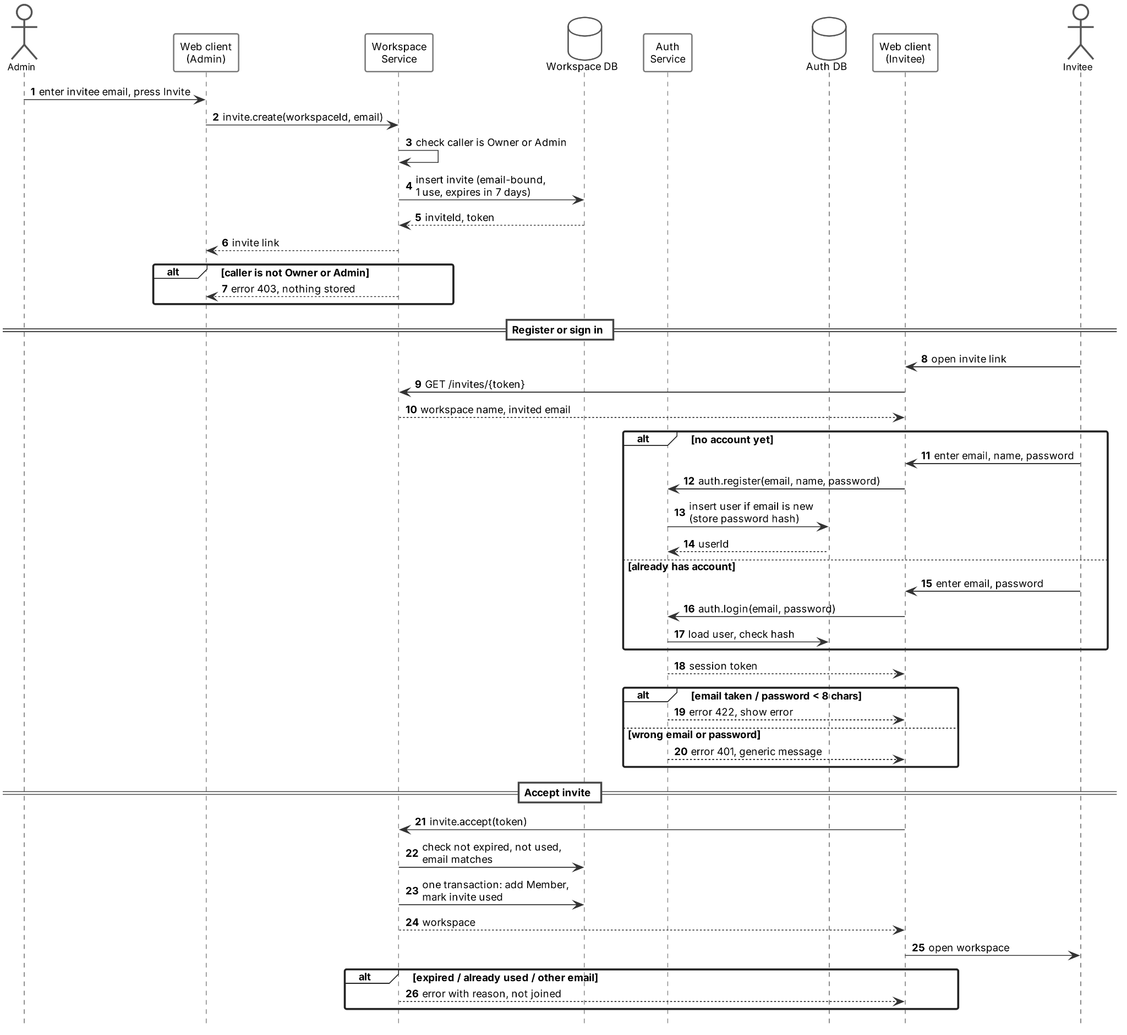

3.2 Channel Message Delivery and Retrieval
This is the core real-time flow. Alice and Bob are in the same channel but connected to different Messaging instances, so the message reaches Bob through RabbitMQ. Order comes from the per-conversation sequence number (seq) assigned in the database transaction (5.4), not from clocks or broker arrival.

UC-04, UC-05 | Send channel message, read message history
Actors | Member (sender), other channel participants; Messaging #1 and #2, Workspace Service, RabbitMQ, PostgreSQL
Requirements | FR-011, FR-012, FR-013, FR-014, FR-021, NFR-003, NFR-005, NFR-010
Precondition | Both users are signed in, are channel participants and have an open WebSocket.
Main flow | - Alice sends a message with a clientRequestId. Her client shows it as "sending".  - Messaging #1 checks with the Workspace Service that Alice can post in the channel.  - In one transaction Messaging #1 assigns the next seq and saves the message and an outbox event.  - Only after the commit, Alice gets an ack and the message is shown as "sent".  - The outbox relay publishes message.created to RabbitMQ.  - Messaging #2 receives the event and pushes the message to Bob, whose client places it by seq.  - Unread counts of the other participants come from their read cursors in Messaging storage.  - When Bob opens the channel, history loads in pages of 50 by seq and his read cursor is saved, so all his sessions show the same unread state.
Failure flows | E1 Ack is lost and the client retries with the same clientRequestId: the unique (conversationId, clientRequestId) key returns the existing message and no new event is published.  E2 User is not a participant or the channel is archived: 403, nothing is saved.  E3 Empty text without an attachment, more than 4,000 characters, or more than five attachments: 422.  E4 RabbitMQ is temporarily down: the message is already committed, and the event waits in the outbox until the broker is back.  E5 RabbitMQ delivers the same event twice (at-least-once): Messaging #2 ignores the repeated eventId.  E6 Client sees a gap in seq (e.g. 12 arrives before 11): it fetches the missing message from history before showing 12.
Postcondition | The message is stored once with a stable seq and all participants see the same order.
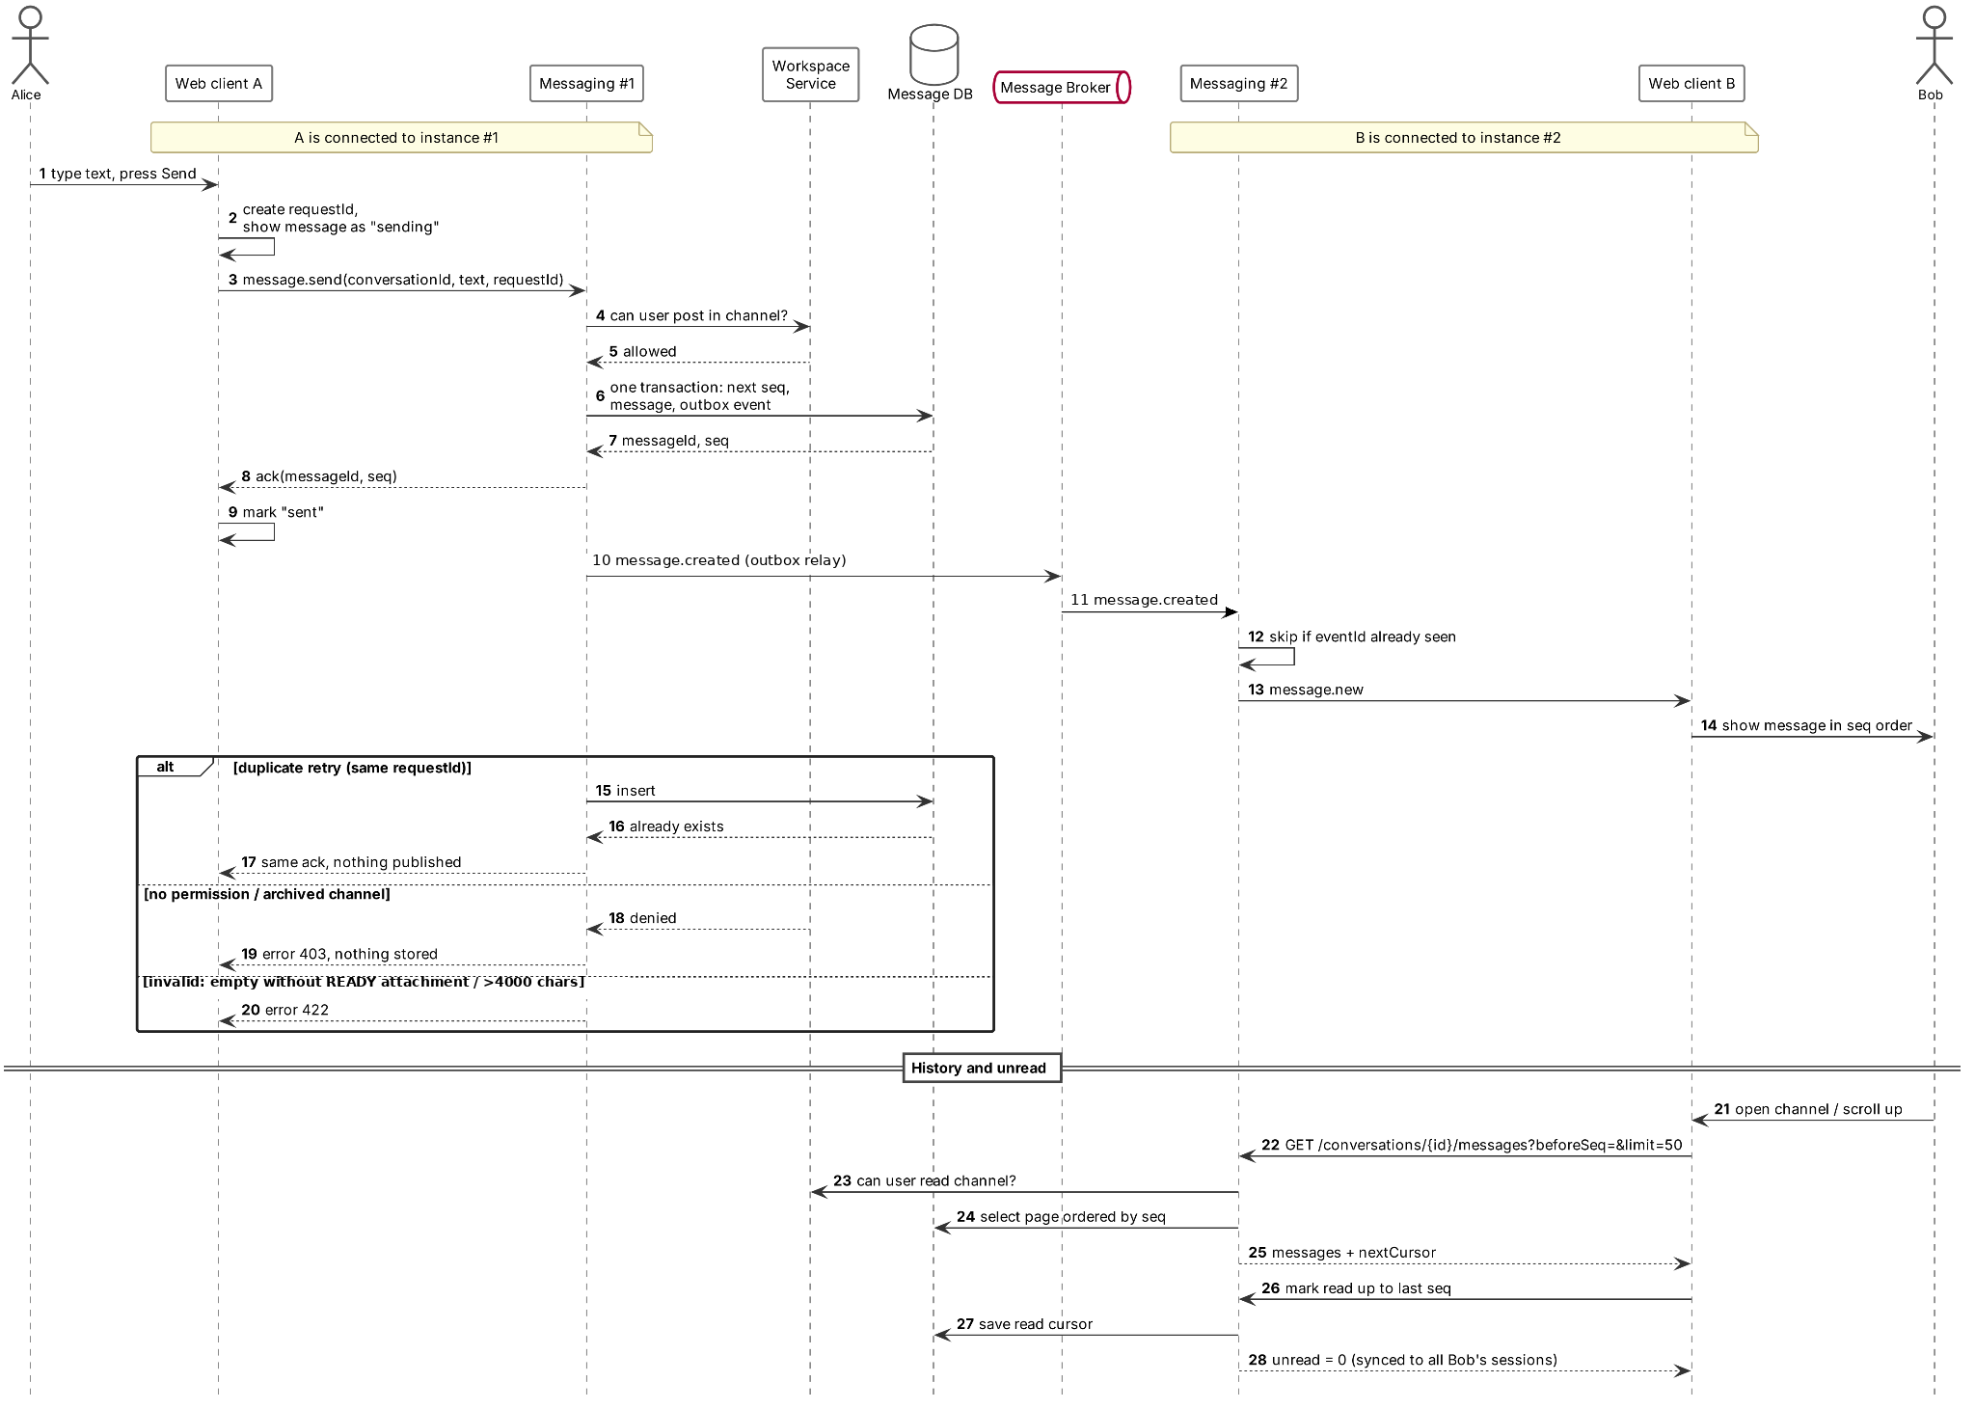

3.3 Creating and Sharing a Collaborative Document
A document belongs to a channel. Creating it is a normal REST call, while opening it joins a live document room over WebSocket (5.5). Alice and Bob are again on different instances.

UC-06, UC-07 | Create and share document, open document
Actors | Member (creator), other channel members; Collaboration #1 and #2, Workspace Service, Messaging Service, RabbitMQ, PostgreSQL
Requirements | FR-027, FR-028, FR-031, FR-034, FR-035
Precondition | Alice has write access to the channel.
Main flow | - Alice chooses "New document" and enters a title (1–100 characters).  - Collaboration #1 checks write access. In one transaction it creates the document with a stable ID, an empty Y.Text state and an outbox event.  - document.created is published. Messaging shows a document card in the channel and updates the channel's document list.  - Bob clicks the card. His client joins the document through Collaboration #2 and sends its Yjs state vector.  - Collaboration #2 checks Bob's access, loads the latest snapshot and later updates, and sends what Bob is missing.  - Bob joins the document room and appears in the active-editors list. Closing the document leaves the room.
Failure flows | E1 Title empty or too long: 422.  E2 No write access or archived channel when creating: 403, no document.  E3 Archived channel when opening: the document opens read-only.  E4 User is not a channel member: 403, the document is neither listed nor opened.
Postcondition | The document exists in the channel and every authorised member, including late joiners, sees the same committed text.

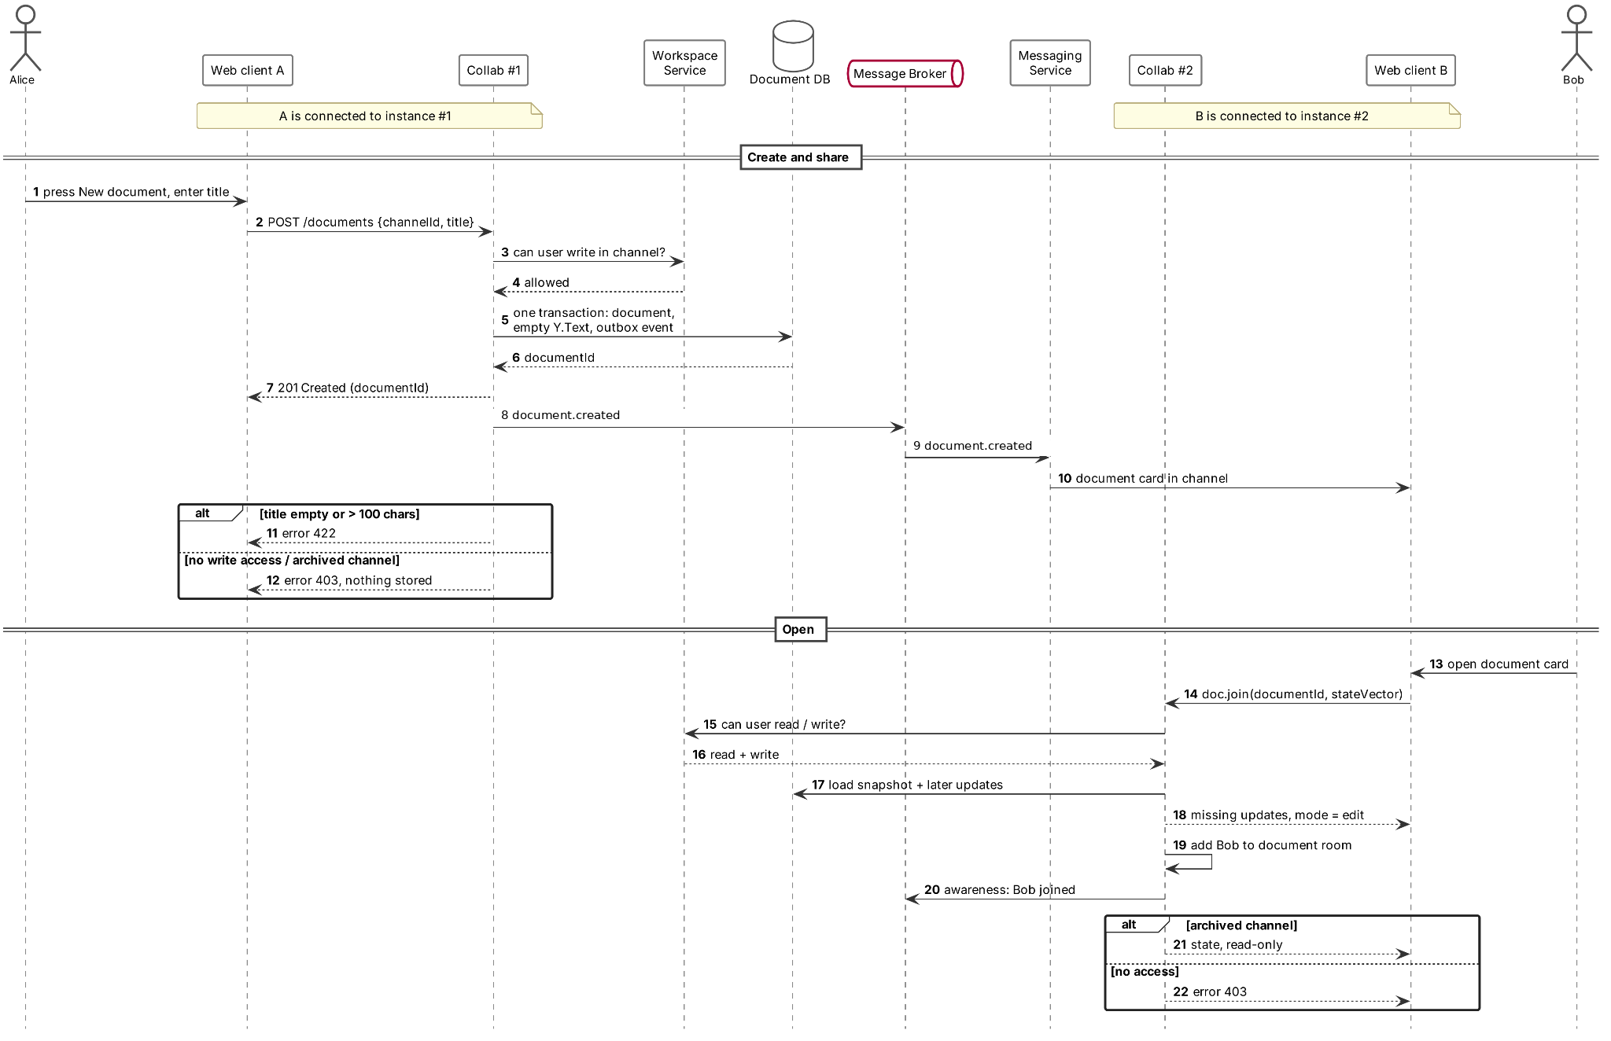

3.4 Simultaneous Editing, Conflict Handling and Synchronization
Concurrent edits use the Yjs Y.Text CRDT chosen as the editing approach (5.5). Each client applies its own edit at once and sends it as an update with a unique updateId. Yjs merges edits independently of event order, but each document's accepted updates must be transactionally serialized when assigning persistence sequence numbers and enforcing the 100,000-character limit. The sequence is for storage/replay, not CRDT conflict resolution. The diagram shows three editors on two instances, as FR-029 requires; Figure 5.4 shows the same synchronization from the node's side.

UC-08 | Edit document together
Actors | Editors A, B and C; Collaboration #1 and #2, RabbitMQ, PostgreSQL
Requirements | FR-029, FR-030, FR-032, FR-034, FR-035, NFR-003, NFR-005, NFR-011
Precondition | A and B use instance #1, C uses instance #2. All three have the document open with the text "Plan v1".
Main flow | - At the same moment A inserts "Final " at the start and C deletes " v1".  - Each client applies its edit locally and sends the Yjs update with its updateId.  - The instance checks access and updateId, then atomically applies the update to the latest committed Yjs state and checks the merged text against the 100,000-character limit (counting Unicode code points).  - The accepted update, next document log seq and outbox event are committed in that same per-document transaction; only then does the author receive an ack.  - The instance forwards the update to its own document room and publishes it to RabbitMQ. The other instance forwards it to its room.  - Every client merges both updates and all three show "Final Plan", whatever the arrival order.  - Caret and typing (awareness) events use the authenticated live route and are broadcast to current editors, but are ephemeral: unlike Yjs document changes, they are not added to the durable document update log or replayed on reconnect. An editor whose presence is not refreshed for 15 s is removed from the active list.
Failure flows | E1 Ack is lost and the same updateId is resent: it is stored once, acknowledged again and not applied twice.  E2 No write access or the merged text would exceed 100,000 characters: the update is rejected. The client shows an explicit error, preserves the rejected local change as unsent for manual recovery, and reloads committed document state so its copy does not drift.  E3 Access is revoked while editing: the instance closes the session and blocks new updates (5.4, NFR-008).  E4 The instance crashes while editing: handled as in 3.5. Acknowledged updates are already in durable storage.
Postcondition | All copies converge to identical text and every acknowledged update is stored exactly once.
About every 100 updates the instance saves a compact snapshot (5.5), so opening a document in 3.3 does not replay the whole update log.
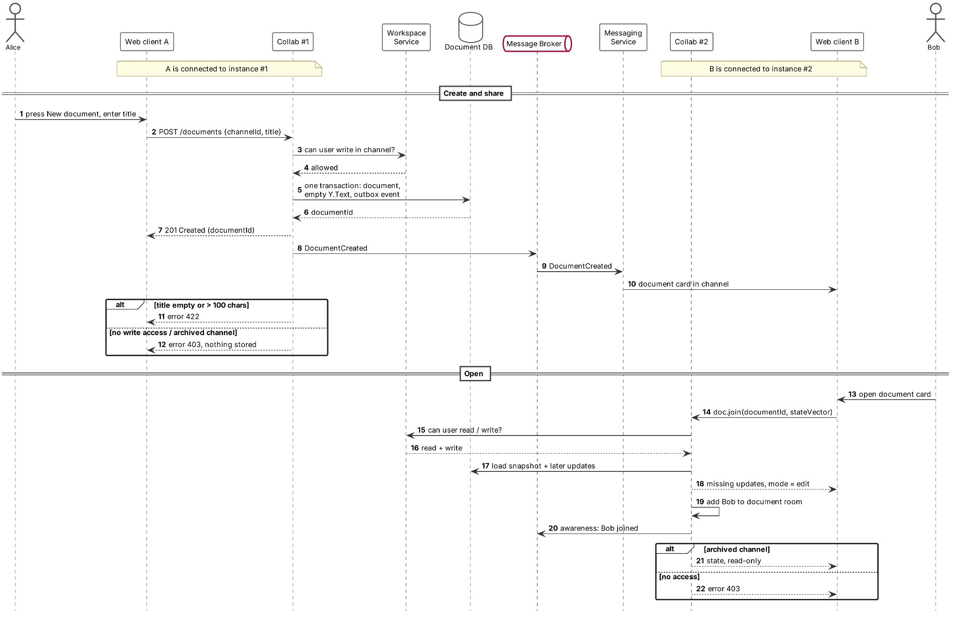

3.5 Disconnect, Reconnect and Service Failure Scenarios
A network drop and an instance crash look the same to the client: heartbeats stop and it reconnects, possibly to another instance. Every acknowledged message and update is already committed, so a stopped instance loses nothing. One activity diagram covers both chat and documents.

UC-09 | Reconnect and catch up
Actors | Synq client (automatic), user; web gateway, Messaging and Collaboration instances, Presence Service
Requirements | FR-013, FR-020, FR-033, NFR-004, NFR-006, NFR-008, NFR-012, NFR-014
Precondition | The client was connected and may have unsent messages or edits.
Main flow | - The client misses heartbeats, shows a "Reconnecting" banner and keeps unsent items in a pending queue.  - It retries with backoff (1, 2, 4 s…). The gateway routes only to instances that pass health checks.  - The new instance validates the session and re-checks access.  - Catch-up: messages after the client's last seq for each open conversation; for documents, the updates missing from the client's state vector, or a snapshot plus later updates.  - The client merges the updates and resends pending items with the same clientRequestId or updateId, so duplicates are ignored.  - Acknowledged items are marked "sent" and the banner disappears.
Failure flows | E1 Session expired: the user goes to sign-in. Pending items stay as "unsent" and are not dropped.  E2 Access revoked in the meantime: "access denied" is shown and pending items are marked "unsent".  E3 A resent item is still not acknowledged: it is marked "unsent" with a Retry button.  E4 A Messaging or Collaboration instance stops: it fails the gateway health check and its clients reconnect to another instance within 15 s. Other users are not affected.  E5 The chosen database, broker or presence store is down: outside the V1 availability guarantees (5.7). Services return 503 and the client shows the failed state.
Postcondition | The client has the same state as the server, no acknowledged work is lost and no pending work disappears silently. When a user's last session has had no heartbeat for 15 s, Presence (Redis) marks the user offline.

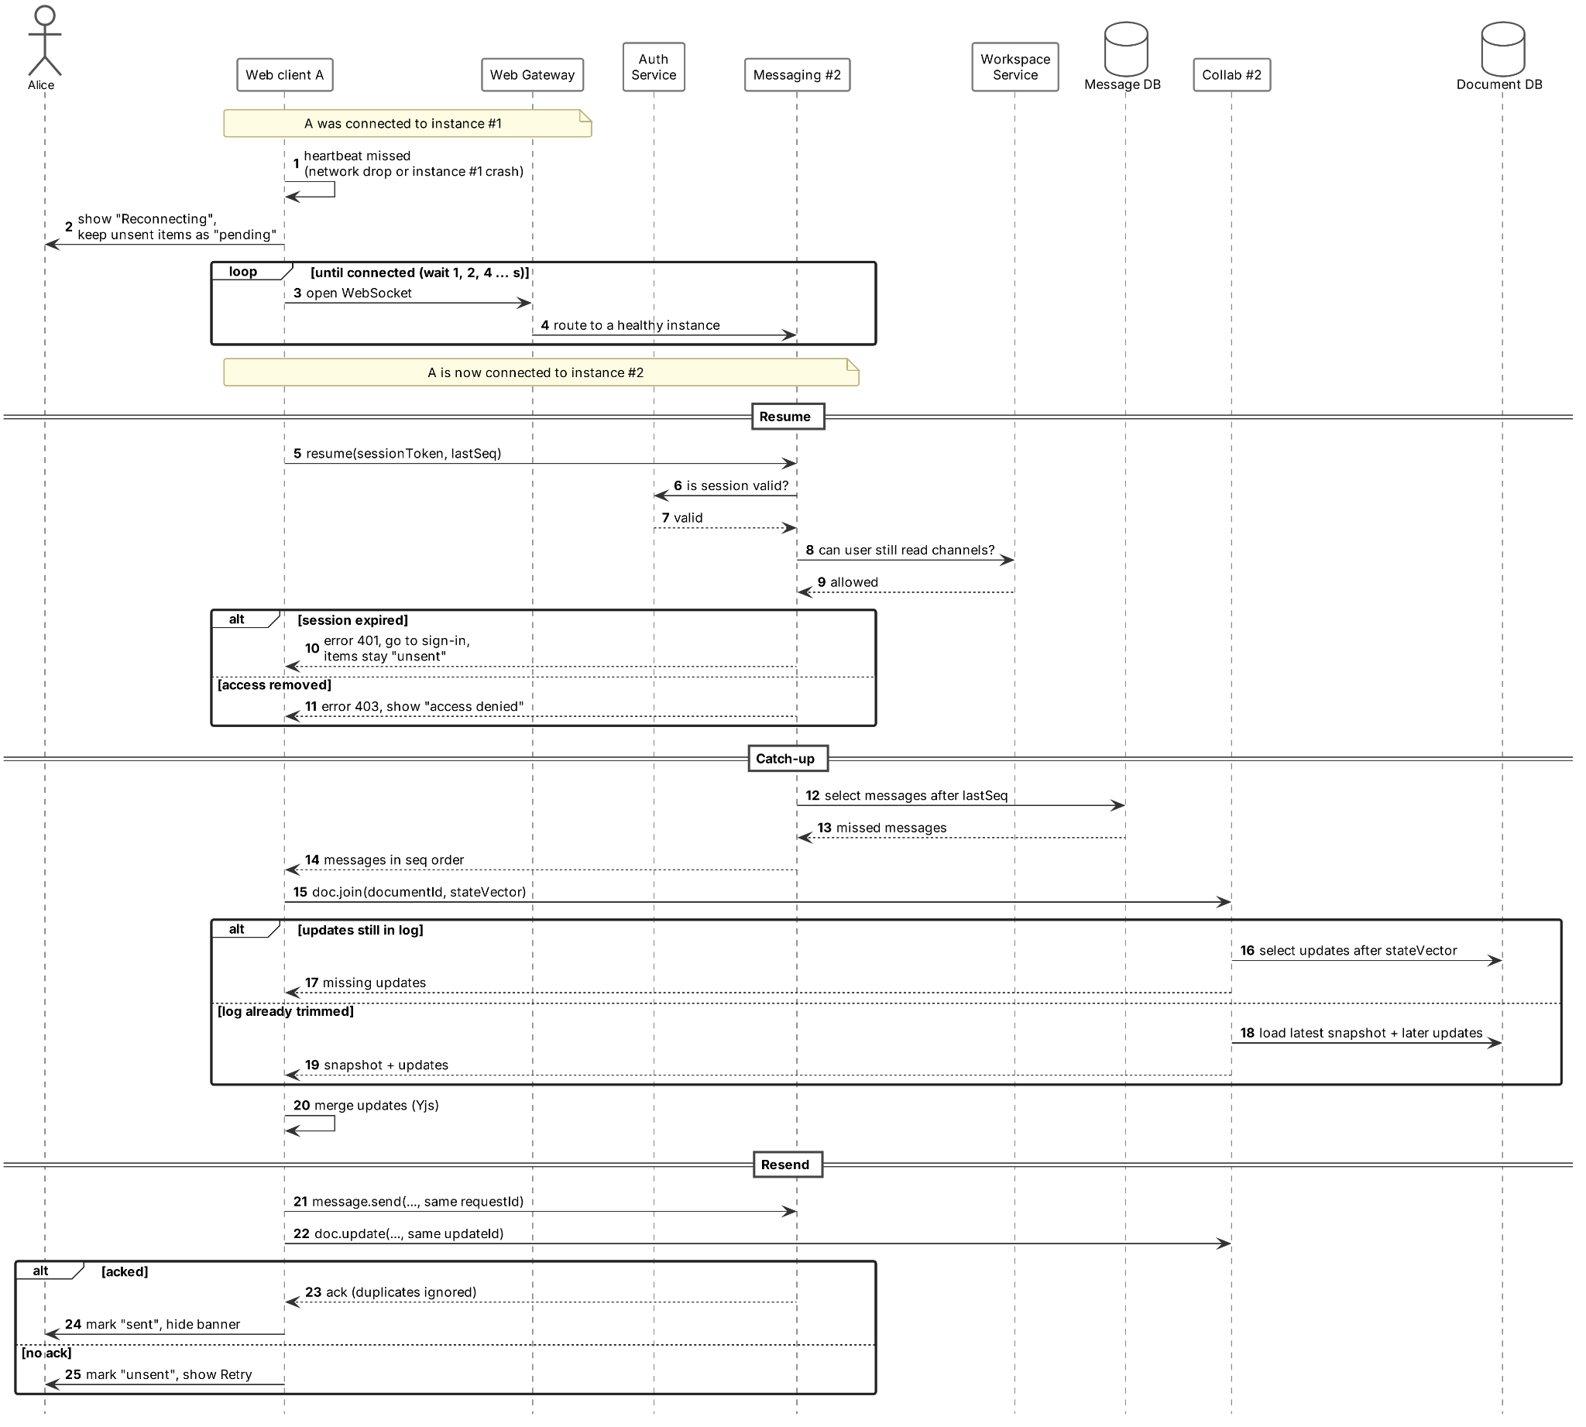

4. Non-Functional Requirements
The requirements below define measurable targets for the V1 system under the scope and deployment assumptions in Section 1.3.

4.1 Performance, Capacity and Response-Time Targets
Benchmark setup: one Docker Compose host with at least 4 logical CPU cores and 8 GiB RAM; the load generator runs separately. Tests use 100 connected clients across up to 50 workspaces, with two Messaging and two Collaboration instances.
- NFR-001 | MUST | Concurrent capacity. Synq shall support 100 simultaneous connected users across 50 workspaces on the specified test setup.
  - Acceptance: All 100 clients remain connected during a 10-minute test without service crashes.
- NFR-002 | MUST | API response time. Under the reference load, 95% of sign-in, workspace/channel listing and message-history requests shall finish within 1 second; file uploads are excluded.
  - Acceptance: The 95th-percentile server response time is at most 1 second for each listed operation.
- NFR-003 | MUST | Real-time propagation. With healthy services and a local test network, 95% of accepted chat messages and text edits shall appear on other connected clients within 1 second.
  - Acceptance: Latency tests across different service instances meet the 1-second threshold.

4.2 Availability, Reliability and Fault Tolerance
- NFR-004 | MUST | Single-instance failure. With shared storage and broker running, stopping one Messaging or Collaboration instance shall not make the service unavailable; affected clients shall reconnect through another instance within 15 seconds.
  - Acceptance: After one instance is stopped, affected clients reconnect and all acknowledged messages/edits remain accessible.
- NFR-005 | MUST | Durable acknowledgements. The system shall acknowledge messages and document edits only after their state is durably recorded; a single service restart must not erase acknowledged work.
  - Acceptance: Restarting a service preserves all acknowledged messages and edits.
- NFR-006 | MUST | Connection recovery. Clients shall show connection loss and recover missed messages/document updates after reconnection, without silently dropping unsent edits.
  - Acceptance: After a brief outage, clients show missing updates and pending edits are retried or marked unsent.

4.3 Security, Authorization, Privacy and Data Retention
- NFR-007 | MUST | Secure credentials and transport. Use salted adaptive password hashing and HTTPS/WSS for non-local deployments; never log passwords or session tokens.
  - Acceptance: Stored passwords are non-reversible hashes, remote connections use TLS, and logs contain no secrets.
- NFR-008 | MUST | Server-side authorization. Every API call and live subscription shall enforce current workspace/channel permissions. When access is revoked, newly attempted operations and outbound protected events must be blocked immediately; affected live subscriptions shall close within 5 seconds.
  - Acceptance: A removed user cannot access restricted data or keep receiving its events.
- NFR-009 | MUST | Data minimization and retention. Treat user messages and documents as potentially personal data. Exclude their contents from diagnostic logs; keep such logs for at most 14 days. Deleted attachments must become inaccessible immediately and be removed from object storage within 24 hours.
  - Acceptance: Log review finds no sensitive content; deleted file access fails immediately and the object is cleaned up within 24 hours.

4.4 Consistency, Message Ordering and Conflict Resolution
- NFR-010 | MUST | Conversation ordering. Messages shall retain one stable order per conversation across nodes and reconnects; retries must not create duplicate accepted messages. No global order is required.
  - Acceptance: Cross-node clients see the same order after a retry/reconnect test.
- NFR-011 | MUST | Collaborative convergence. Concurrent text operations from at least three editors on two Collaboration instances shall converge to identical text; duplicate operations must be idempotent.
  - Acceptance: After concurrent inserts/deletes and event replay, all editors see identical text without lost acknowledged edits.
- NFR-012 | MUST | Distributed activity state. Unread positions and online presence shall synchronize across a user's sessions; healthy-client updates shall appear within 2 seconds, and expired sessions must disappear within 15 seconds.
  - Acceptance: Two sessions show matching unread status and presence after updates and disconnects.

4.5 Usability, Accessibility and Observability

- NFR-013 | MUST | Browser support and accessibility. The web client shall work in current desktop Chrome, Firefox and Edge, with keyboard access and visible focus for all core screens.
  - Acceptance: Core login, messaging and editing flows work without mouse-only controls in all three browsers.
- NFR-014 | MUST | Error and connection feedback. The UI shall show clear access-denied, loading, failed-operation and disconnected states without presenting unsaved changes as accepted.
  - Acceptance: Users can distinguish saved, pending and failed actions and retry when connection returns.
- NFR-015 | MUST | Monitoring and diagnostics. Each service shall expose a health endpoint and produce structured logs with request/correlation IDs; logs must exclude passwords, tokens and message/document contents.
  - Acceptance: A failed service is visible through health checks and its request trace can be followed across services.

5. High-Level Architecture
This chapter defines V1 service boundaries, communication, storage and recovery. Technology choices are proposed design decisions; diagrams show logical components running on one host.

5.1 System Context and Deployment Topology
Synq has a browser client and independent backend services. HTTPS serves API requests; authenticated WebSockets carry live messages, edits and presence. The gateway routes traffic, while services enforce access rules. Storage and broker endpoints are private.
Messaging and Collaboration each run at least two instances on one Docker Compose host. They exchange events and share durable storage; V1 does not require separate physical machines.
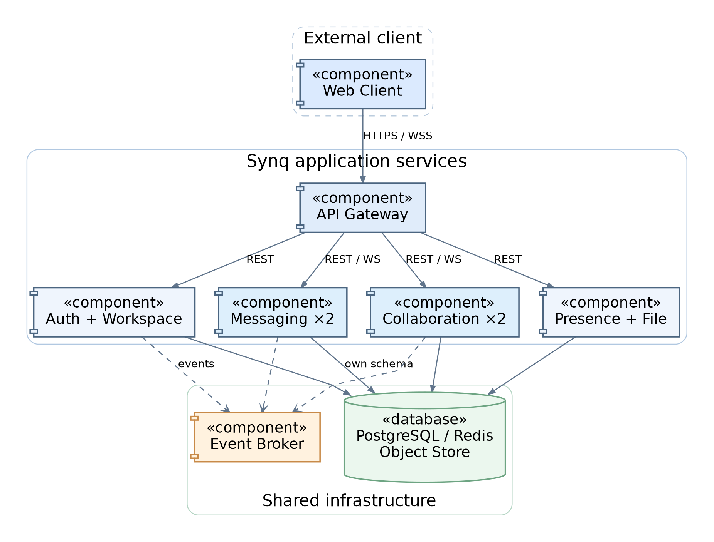
Figure 5.1. UML Component Diagram — client, services and shared infrastructure.

5.2 Services, Modules and Package/Class Diagrams
Responsibilities and owned modules:
- Auth Service — accounts, password hashes and sessions.
- Workspace Service — workspaces, channels, memberships, roles and invitations.
- Messaging Service (2+ instances) — message history, ordering, deduplication and live delivery.
- Collaboration Service (2+ instances) — document permissions, CRDT updates, snapshots and subscriptions.
- Presence Service — session heartbeats, expiry and online status.
- File Service — attachment metadata, validation and protected storage access.
- Search and Notification Services (SHOULD) — optional search and in-app alerts; failures must not block core services.
Each service separates API handlers, business logic and persistence. Messaging owns sequencing and the outbox; Collaboration owns CRDT updates and subscriptions. Other services interact through APIs/events, not direct table writes.
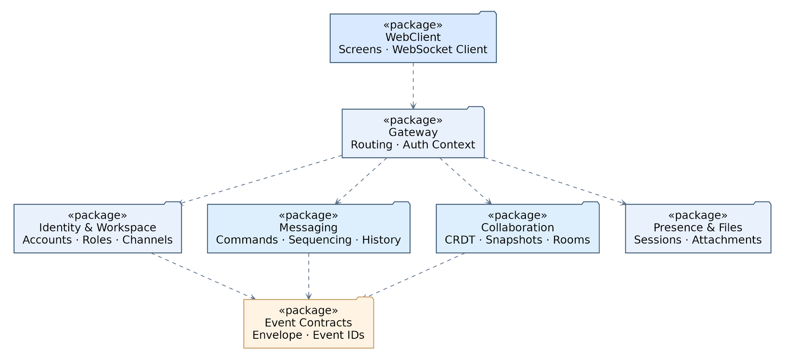
Figure 5.2. UML Package Diagram — service packages and dependencies.
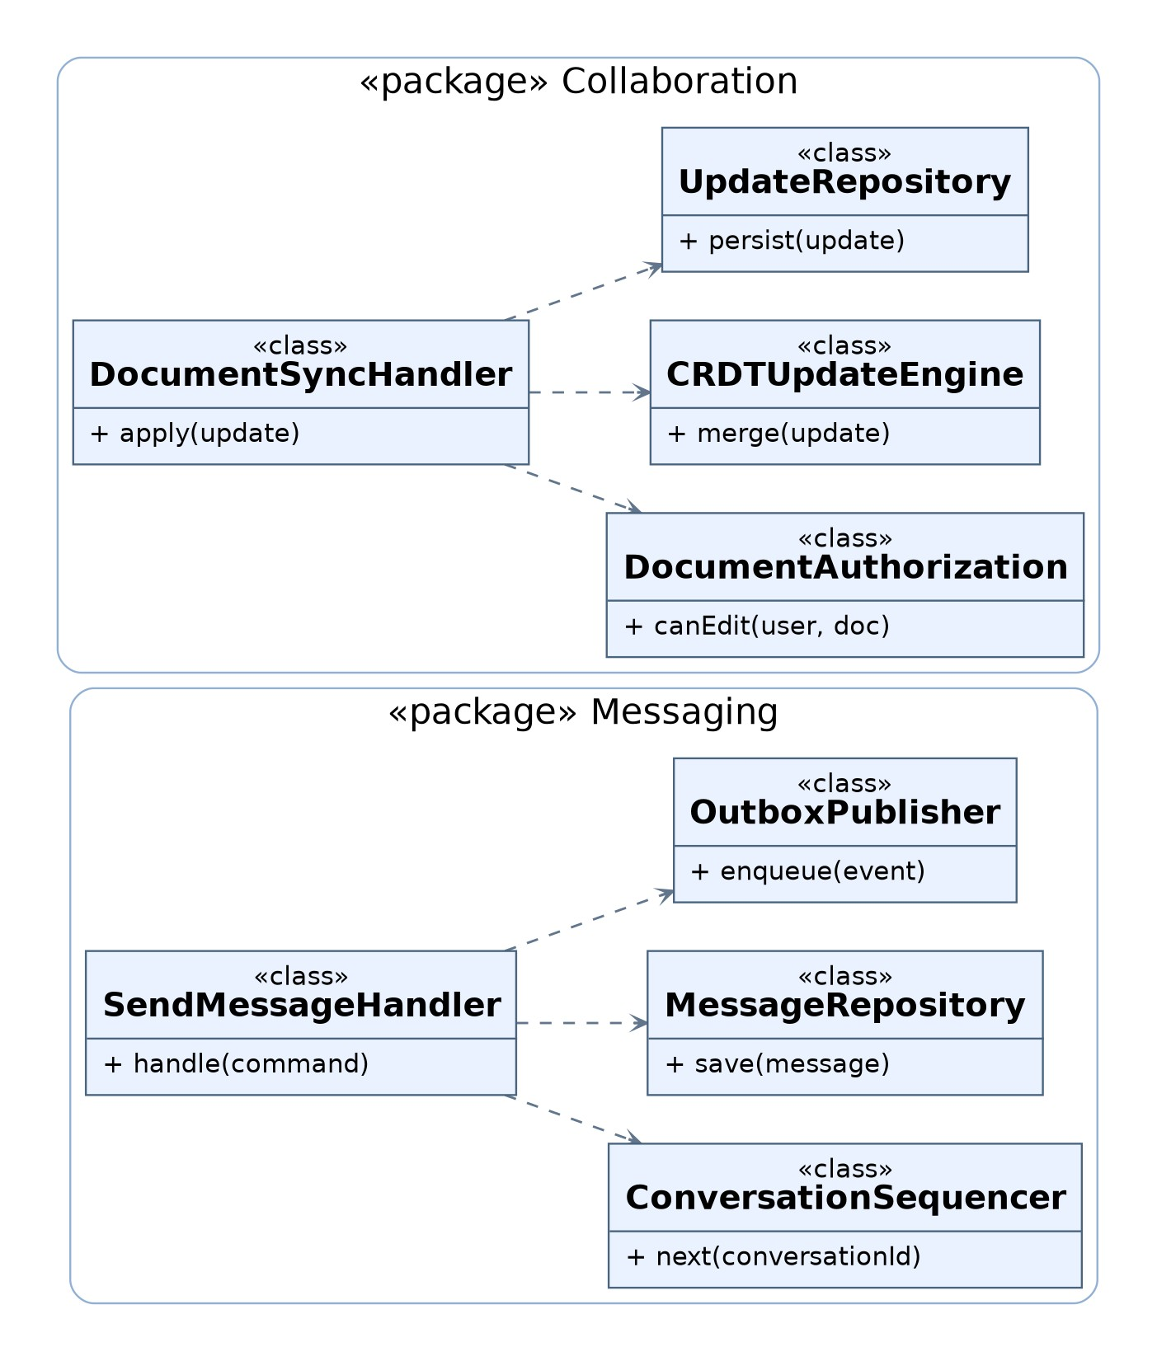

Figure 5.3. UML Class Diagram — key Messaging and Collaboration modules.

5.3 Inter-Service Communication and Message Broker
Clients use HTTPS/REST and authenticated WebSockets. Services exchange events through a durable broker (RabbitMQ in the reference deployment), with at-least-once delivery, acknowledgements and consumer deduplication.
A database transaction saves the state change and outbox record. A relay publishes with confirmation; consumers deduplicate by eventId. Event fields are eventId, eventType, aggregateId, workspaceId, schemaVersion, occurredAtUtc and payload.
Only an owning service authorizes and commits commands. Broker delivery does not define message order.

5.4 Distributed Real-Time Messaging and Presence
A Messaging node validates conversationId, text and clientRequestId. In one transaction it assigns the next conversation sequence, saves the message and outbox event, then acknowledges. message.created events reach subscribers across nodes; reconnecting clients fetch messages after their last sequence.
A unique (conversationId, clientRequestId) prevents duplicate retries. Transactional sequence numbers, not clocks or broker arrival, establish conversation order.
Redis heartbeats track active sessions; users stay online while any session is active. Durable read cursors remain in Messaging storage. Membership revocation closes subscriptions and blocks new access.

5.5 Collaborative Editing Architecture (Yjs CRDT)
Architecture decision: Synq V1 uses the Yjs Y.Text CRDT for shared plain-text editing. Its updates are commutative, associative and idempotent, allowing replicas to converge after concurrent edits. Editors load missing CRDT updates via state vectors and join a document room. For each update, a node checks access and atomically validates the merged state against the latest committed document before saving updateId, log seq, update bytes and an outbox event; acknowledgement follows commit. Nodes replay committed updates; restart recovery uses snapshots and the update log.
A client updateId tracks retries; CRDT operations remain idempotent. Compact snapshots (initially about every 100 updates) accelerate recovery. Check the 100,000-character limit against merged text before accepting updates.
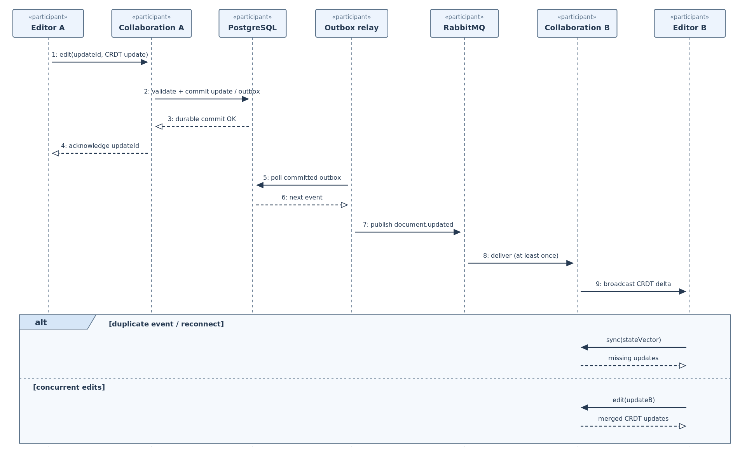
Figure 5.4. UML Sequence Diagram — durable CRDT synchronization across nodes.

5.6 Data Ownership, Persistence and Replication
A transactional database (PostgreSQL in the reference deployment) may contain service-owned schemas: Auth/Workspace owns users and memberships; Messaging owns conversations, messages, read cursors and outbox; Collaboration owns documents, updates and snapshots; File owns attachment metadata. Only each owner writes its schema.
Redis holds a reconstructible presence state, while S3-compatible storage holds file bytes. Acknowledgements require durable database commits, not Redis or in-memory rooms.
Replicas share their service's durable store. Scaling increases processing and WebSocket capacity; a single database, broker, Redis and object store remain V1 infrastructure failure points.

5.7 Horizontal Scaling, Failover and Recovery

The reference Docker Compose deployment runs the web gateway, Auth, Workspace, Presence, File, two Messaging nodes and two Collaboration nodes, plus a database (e.g., PostgreSQL), presence store (e.g., Redis), broker (e.g., RabbitMQ) and object storage on one host. Search and Notifications are optional.
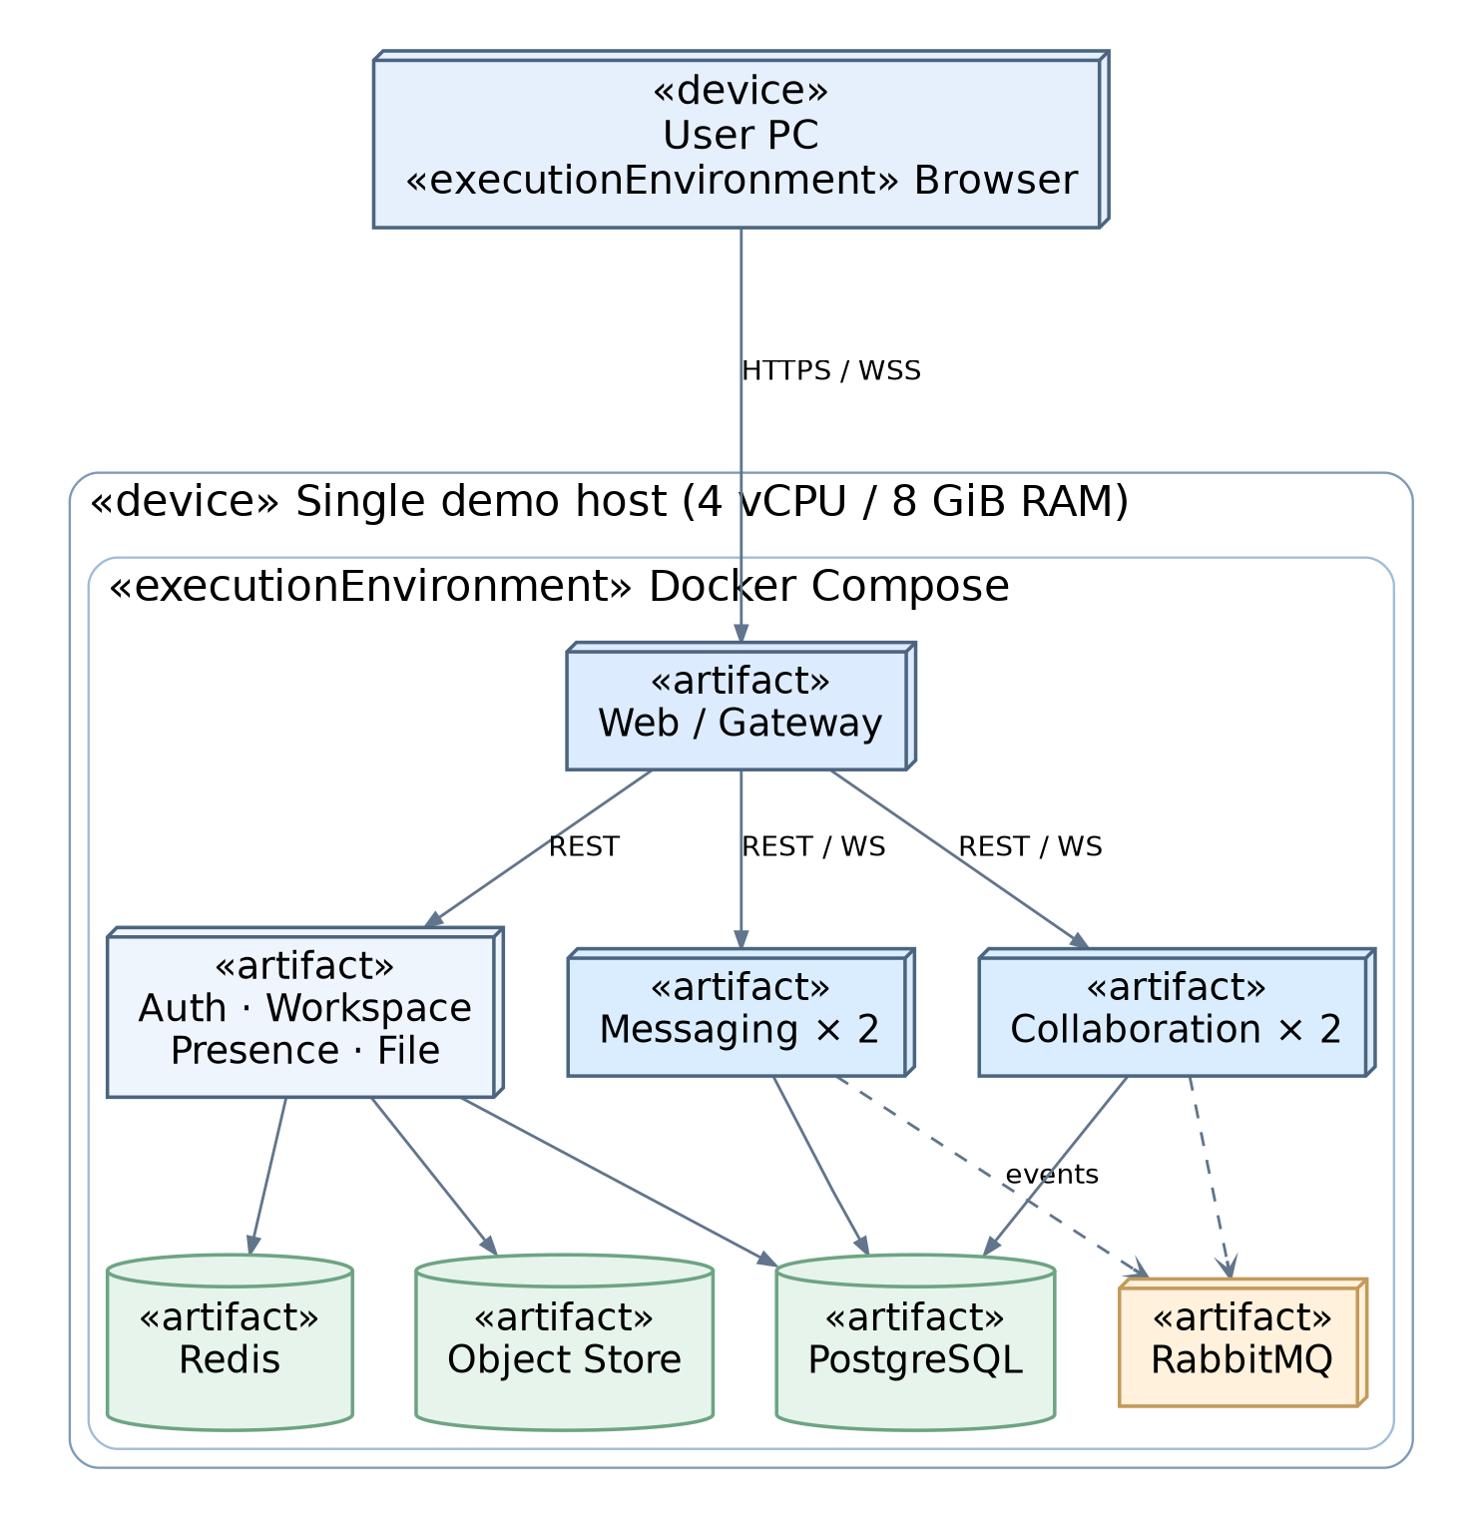
Figure 5.5. UML Deployment Diagram — single-host Docker Compose topology.
The gateway routes new requests and WebSockets to healthy nodes. On instance failure, clients reconnect within 15 seconds and catch up using message sequences or CRDT state vectors. Acknowledged work remains durable.
Health checks and correlated logs support diagnosis. Tests stop one Messaging or Collaboration instance and verify recovery, replay and convergence. Single-host, broker or storage failures remain outside V1 availability guarantees.
This section records the Yjs CRDT decision and the reference client, transport, broker and storage technologies.

6. API Contracts and Real-Time Protocols
Synq has three kinds of interface: a versioned REST API (HTTPS, JSON) for commands and queries, two WebSocket protocols for live delivery (messaging and document sync), and internal events between services through RabbitMQ. The complete REST contract, with every path, verb, parameter, request/response schema and status code, is in the team repository and can be opened in https://editor.swagger.io/. The YAML file in the team repository is authoritative for REST endpoints, WebSocket frames and internal event schemas.

7. Data Model
These class-style diagrams define data fields and constraints. PostgreSQL schemas/types are illustrative; equivalent stores must preserve ownership, atomic writes, unique keys, ordering and authorization. Services exchange data via APIs/events, not direct cross-service writes.
Conventions
- Each class is a table, or a Redis record where the stereotype says so. PK, UK and FK mark keys; several PK markers form a composite key, and foreign keys exist only inside one owner's store. NULL means optional and DEFAULT x marks a default. A dotted arrow is a cross-service reference, not a foreign key.
- Types are examples. Column names are snake_case, and timestamp columns end in _utc.

7.1 Users, Workspaces, Memberships and Roles
Auth owns users/sessions; Workspace owns workspaces, memberships and invitations (FR-001–008).
Diagram 7.1 — Auth schema
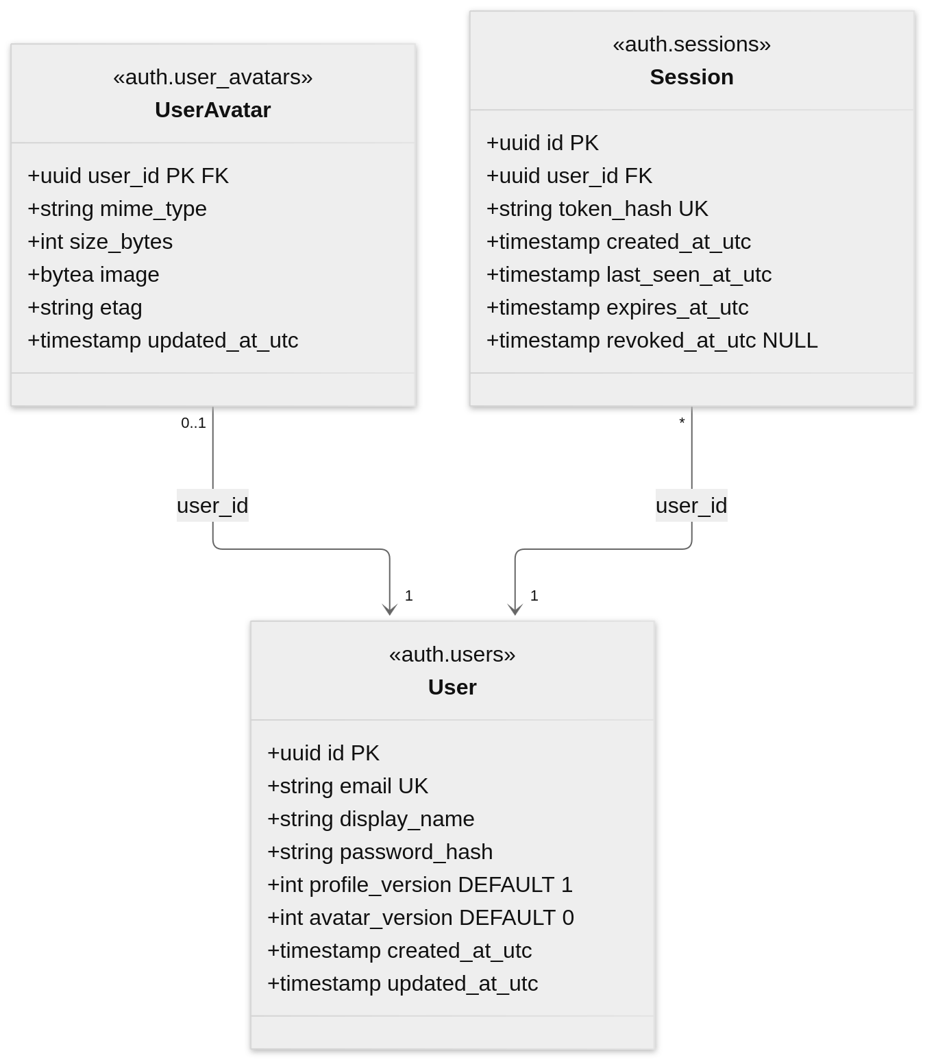
Entity | Rules
User | Email is stored lower-case. profile_version and avatar_version advance on every change.
Session | Only the SHA-256 token_hash is stored. Valid until the earlier of 24 hours idle and 7 days absolute expiry, unless revoked.
Diagram 7.2 — Workspace schema: workspaces, members and invitations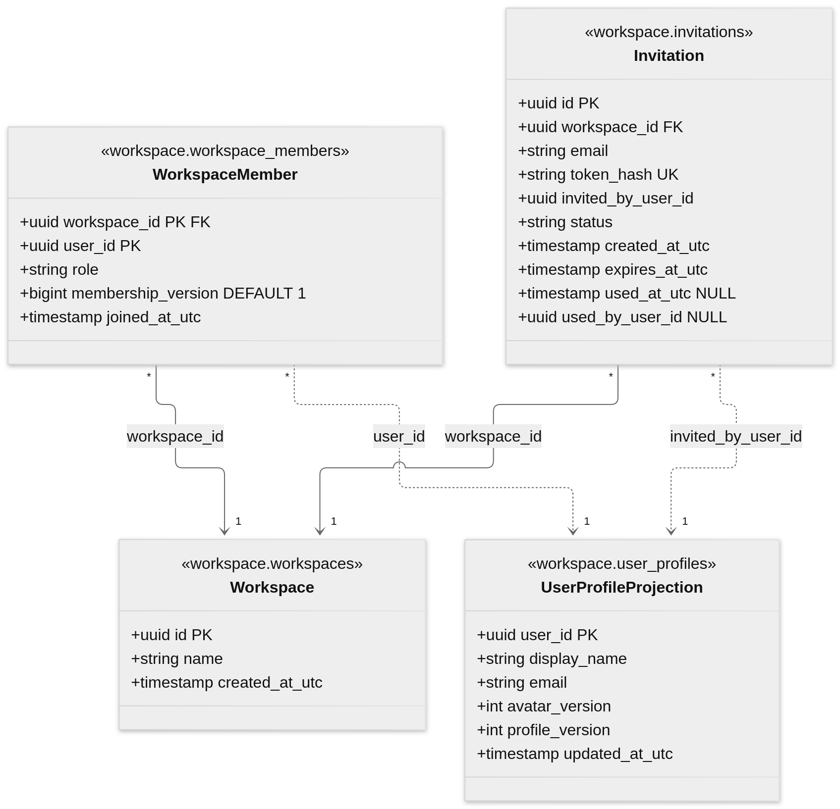
Entity | Rules
WorkspaceMember | Exactly one OWNER per workspace; ownership transfer is atomic. membership_version is monotonic per workspace and user.
Invitation | Only the token hash is stored. At most one PENDING invitation per workspace and email. EXPIRED is derived from expires_at_utc.
UserProfileProjection | Applied only when profile_version is higher. Holds the email used for member lists and invitation matching.

7.2 Channels, Messages, Threads and Reactions
Workspace owns channels; Messaging owns conversations, messages and read cursors (FR-009–019, FR-021).
Diagram 7.3 — Workspace schema: channels, participants and audit records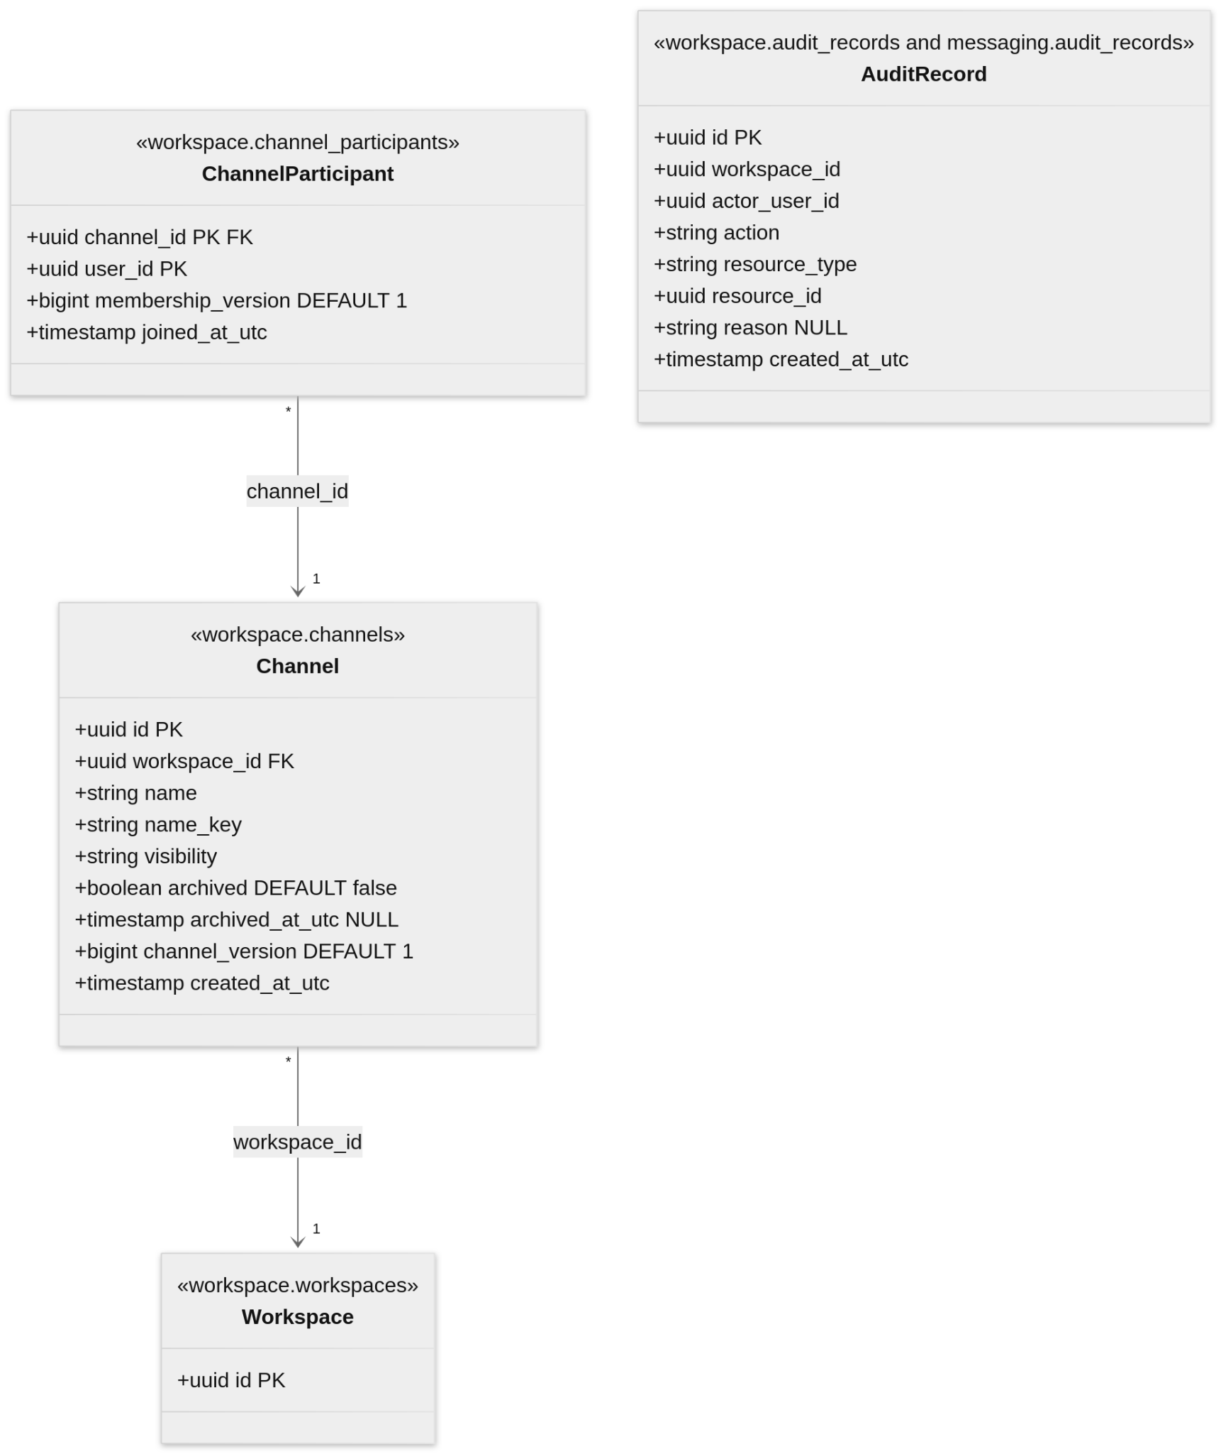
Entity | Rules
Channel | The id is also the id of the CHANNEL conversation. name_key is the lower-cased name, unique per workspace including archived channels. archived is permanent.
ChannelParticipant | The creator is the first participant. The Owner and Administrators need no row. membership_version is monotonic per channel and user.
AuditRecord | Append-only. Messaging writes MESSAGE_DELETED and Workspace writes CHANNEL_ARCHIVED.
Diagram 7.4 — Messaging schema: conversations, messages, threads, reactions, attachments and read cursors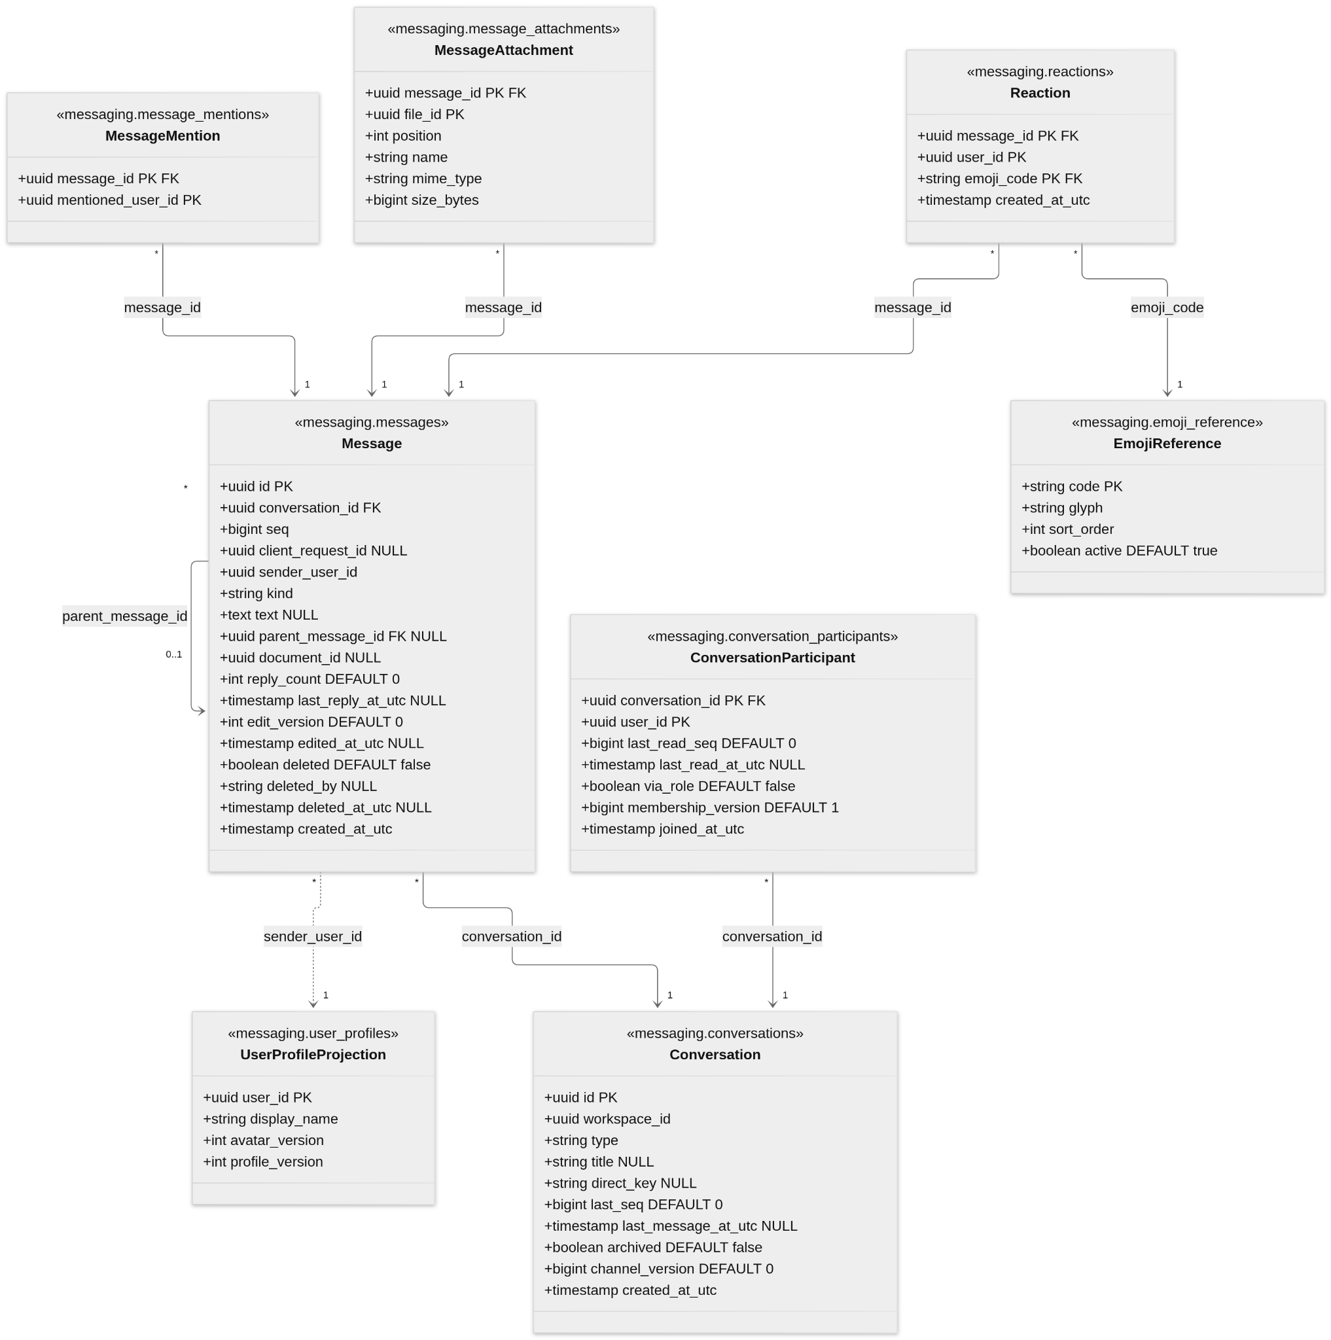
Entity | Rules
Conversation | A CHANNEL conversation has its channel's id. DIRECT is unique per workspace and pair (direct_key is the two ids, sorted). last_seq allocates message order.
ConversationParticipant | last_read_seq is monotonic and at most last_seq. via_role marks an Owner or Administrator who reads a channel without being a participant; the row is removed when the role is lost. Unread and mention counts are computed from last_read_seq. A removed workspace member's rows are deleted.
Message | Unique (conversation_id, seq). Unique (conversation_id, client_request_id) where not null (null for DOCUMENT_CARD and SYSTEM). text is NULL only for a tombstone and empty only for a USER message with attachments. A reply's parent is a top-level message of the same conversation. Deletion keeps id and seq; deleted_by is AUTHOR or MODERATOR.
MessageAttachment | file_id refers to the File Service; name, type and size are snapshots.
Storing a message (3.2, 5.4). One transaction per message: look up client_request_id, lock the conversation row, increase last_seq, insert the message and its outbox event. The ack follows the commit.

7.3 Documents, Participants, Edit Operations and Versions
Collaboration owns documents, binary Yjs updates and snapshots (FR-027–039). Rebuild text from the latest snapshot plus subsequent updates.
Diagram 7.5 — Collaboration schema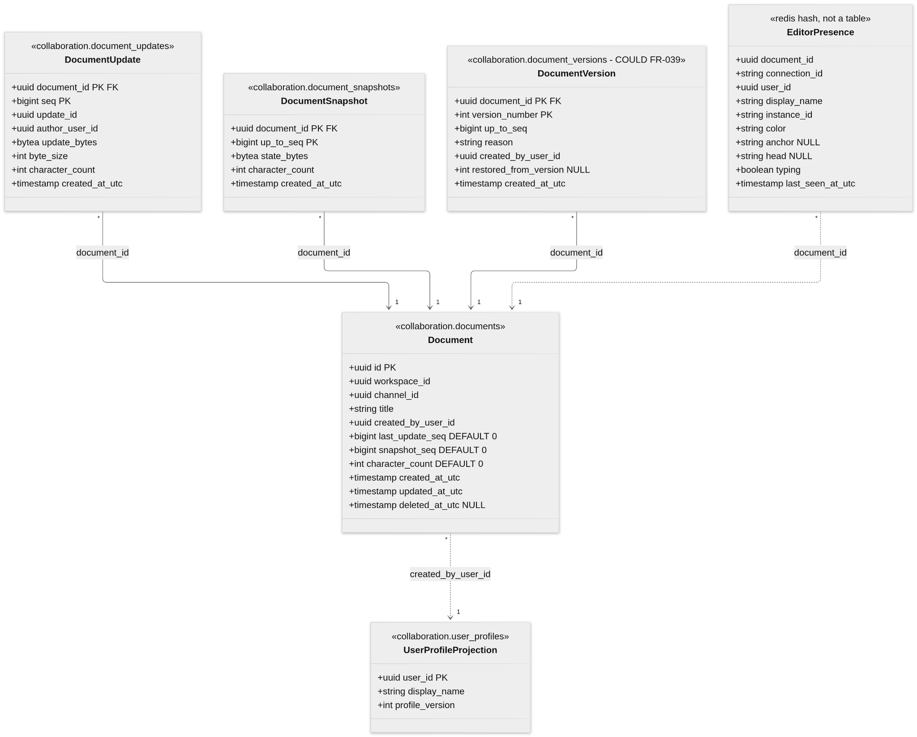
Entity | Rules
Document | channel_id refers to the Workspace schema. last_update_seq orders the update log, not CRDT merges. Soft-deleted through deleted_at_utc.
DocumentUpdate | One transaction per update validates the merged state, allocates seq and writes the outbox event. Unique (document_id, update_id) makes retries idempotent.
DocumentSnapshot | The three latest snapshots, and those used by versions, are kept.
DocumentVersion (COULD) | A restore creates a new update; history is not rewritten.
EditorPresence | Ephemeral and rebuildable; TTL 15 seconds, refreshed at least every 10 seconds.

7.4 Files, Presence, Sessions and Notifications
Files and presence are MUST; Search/Notification entities are SHOULD (FR-020, FR-022–026).
Diagram 7.6 — File schema
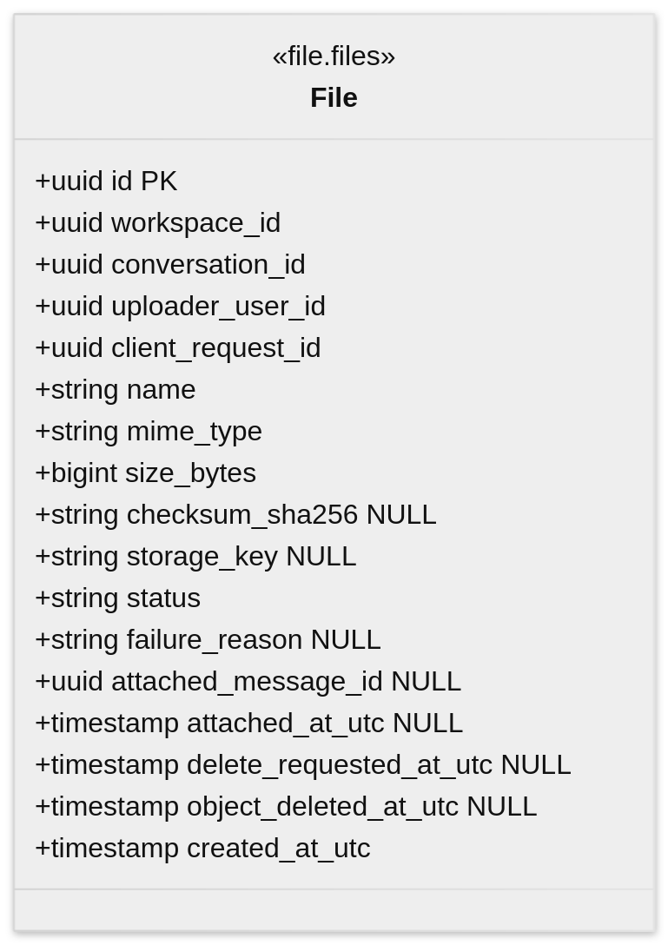
Entity | Rules
File | Metadata only; the bytes are in object storage under storage_key. Unique (uploader_user_id, client_request_id).
Attachment tracking | message.created sets attached_message_id; message.deleted sets delete_requested_at_utc.
Diagram 7.7 — Notification and search schemas (SHOULD)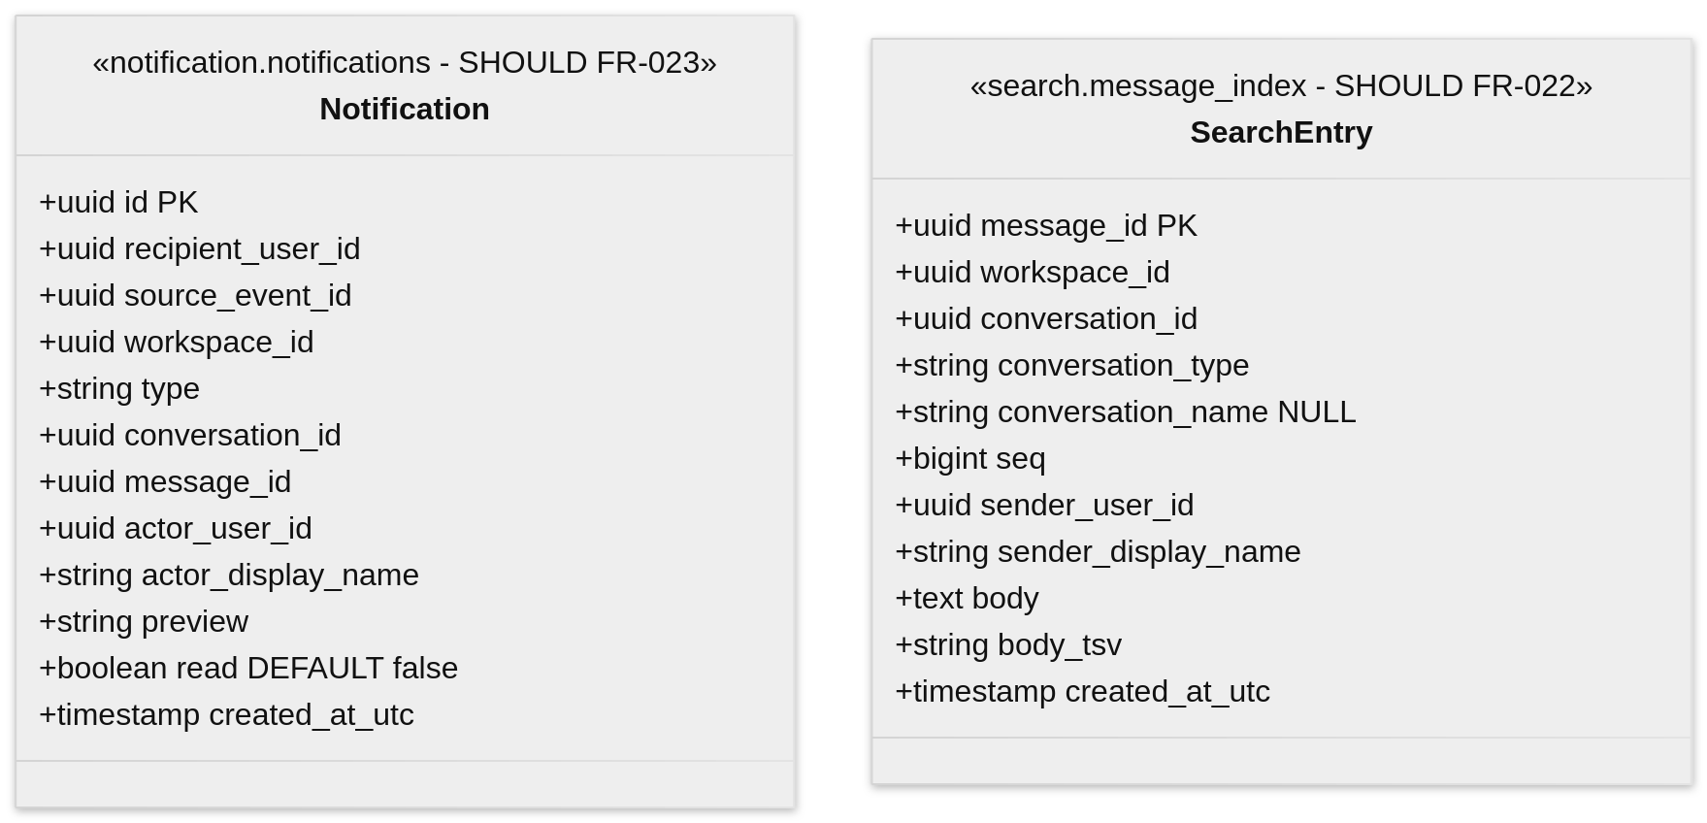
Entity | Rules
Notification | Unique (recipient_user_id, source_event_id) prevents duplicates.
SearchEntry | Rebuildable from message events; results are filtered by current access. A GIN index on body_tsv is an example.
Diagram 7.8 — Presence membership and Redis records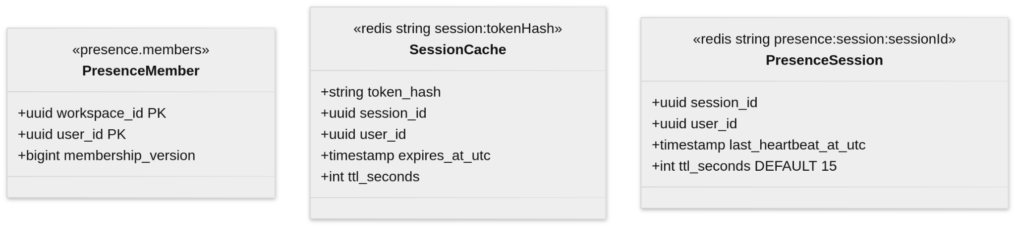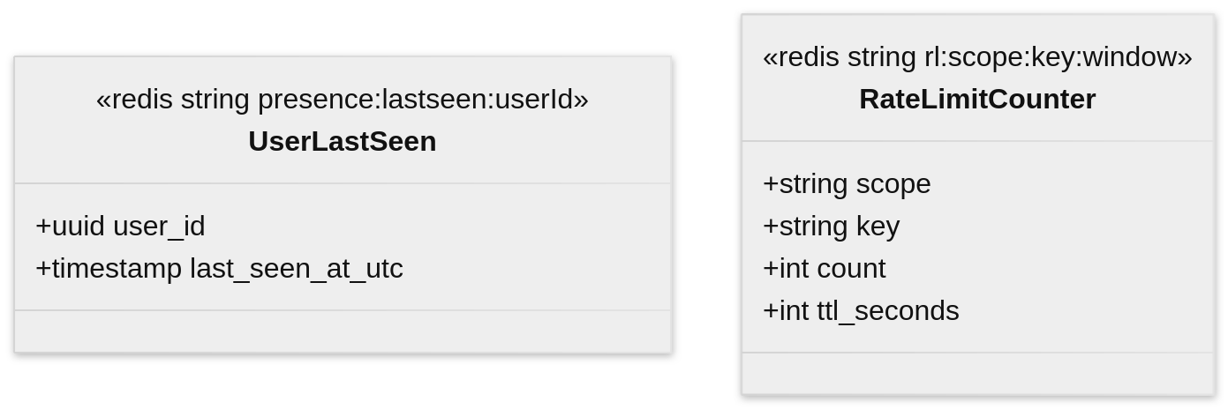
Entity | Rules
PresenceMember | Versioned from member events.
PresenceSession | TTL 15 seconds, refreshed by the 10-second heartbeat.
SessionCache | The sessions table is authoritative.
RateLimitCounter | Email keys are hashed.

7.5 Database Ownership, Indexes and Integrity Constraints
Each publishing service stores outbox events, and each durable consumer keeps processed-event records for deduplication.
Diagram 7.9 — Outbox and processed events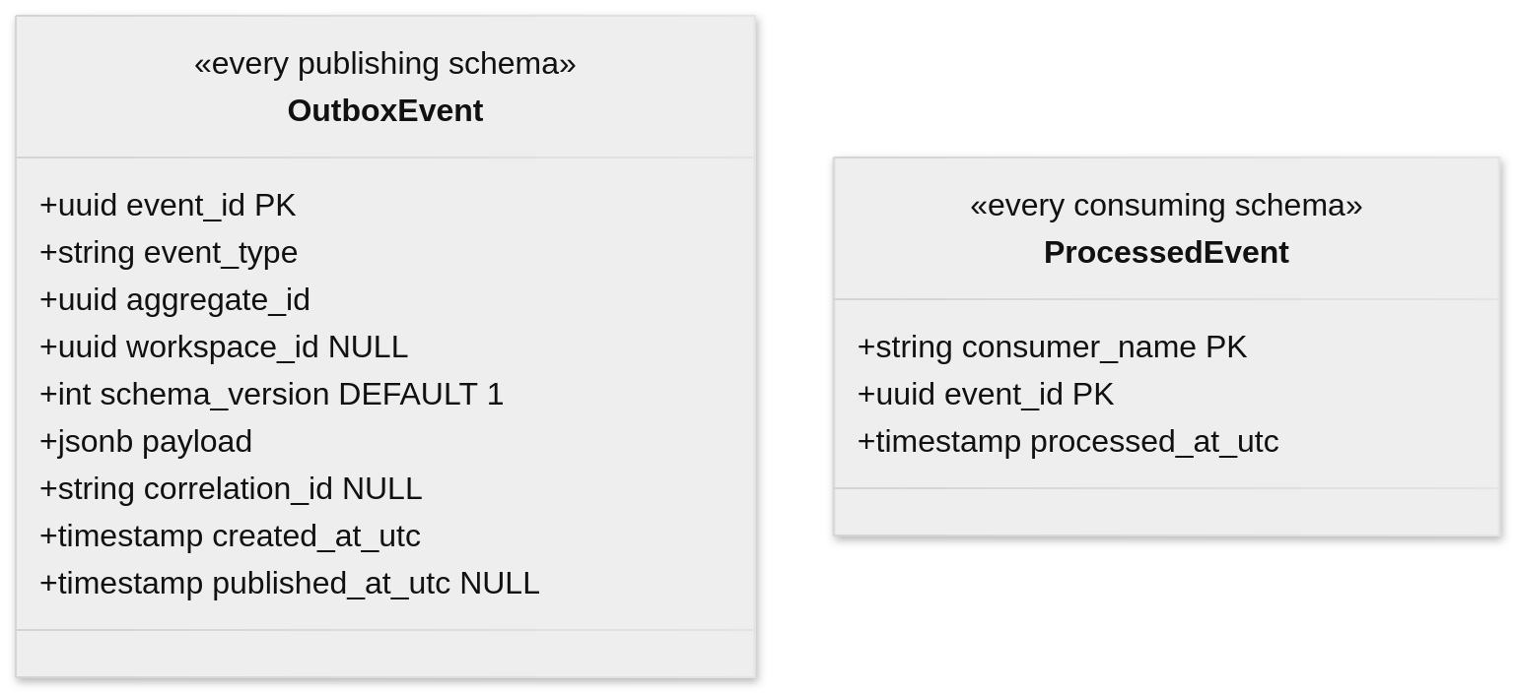
OutboxEvent is saved atomically with the state change and published by a relay. ProcessedEvent is saved in the same transaction as the consumer's change, so redelivery is idempotent (5.3).
Data ownership (only the owning service writes)
Schema or store | Owner | Tables and records
auth | Auth Service | users, user_avatars, sessions, outbox_events
workspace | Workspace Service | workspaces, workspace_members, invitations, channels, channel_participants, audit_records, user_profiles, outbox_events, processed_events
messaging | Messaging Service (all instances) | conversations, conversation_participants, messages, message_mentions, reactions, emoji_reference, message_attachments, user_profiles, audit_records, outbox_events, processed_events
collaboration | Collaboration Service (all instances) | documents, document_updates, document_snapshots, document_versions (COULD), user_profiles, outbox_events, processed_events
file | File Service | files, processed_events
search | Search Service (SHOULD) | message_index, processed_events
notification | Notification Service (SHOULD) | notifications, outbox_events, processed_events
presence | Presence Service | members, processed_events
Redis | Several, by key prefix | session:, presence:, doc:{id}:editors, rl:
Object storage | File Service | Attachment bytes by storage_key
Enumerations (reference values)
Column | Values
workspace_members.role | OWNER, ADMINISTRATOR, MEMBER
invitations.status | PENDING, USED, REVOKED (EXPIRED is derived)
channels.visibility | PUBLIC, PRIVATE
conversations.type | CHANNEL, DIRECT, GROUP
messages.kind | USER, DOCUMENT_CARD, SYSTEM
messages.deleted_by | AUTHOR, MODERATOR
files.status | UPLOADING, READY, FAILED
notifications.type | DIRECT_MESSAGE, MENTION
audit_records.action | MESSAGE_DELETED, CHANNEL_ARCHIVED
document_versions.reason (COULD) | MANUAL, RESTORE
Critical uniqueness constraints (reference indexes)
Table | Constraint or index
users | unique (email)
sessions | unique (token_hash); lookups by user and expiry
workspace_members | unique (workspace_id) where role = OWNER; lookup by user
invitations | unique (token_hash); one pending (workspace_id, email); lookup by email
channels | unique (workspace_id, name_key)
conversations | unique (workspace_id, direct_key) where type = DIRECT
conversation_participants | lookup by (user_id, conversation_id) for my conversations and unread counts
messages | unique (conversation_id, seq); unique (conversation_id, client_request_id) where not null; replies by parent
reactions | primary key (message_id, user_id, emoji_code)
document_updates | unique (document_id, update_id)
files | unique (uploader_user_id, client_request_id); cleanup by status and attachment
notifications | unique (recipient_user_id, source_event_id)
outbox_events | index on created_at_utc where published_at_utc is null
Core data limits (see Section 2 and API YAML)
Data | Constraint
users | Lowercase email ≤254 chars; display name 1–50; avatar ≤2 MiB.
Names and titles | Workspace 2–64, channel 2–50, document 1–100 chars.
messages | Text ≤4,000; empty only with attachment; tombstone text NULL.
Documents | Yjs update ≤1 MiB; merged text ≤100,000 code points.
files | File ≤10 MiB; PNG/JPEG/PDF/TXT only.
Conversations | DIRECT 2 people; GROUP 3–20 (including creator).
Transactional invariants
- Exactly one OWNER per workspace at all times.
- Message seq and document update seq are allocated atomically in the owning transaction.
- State changes commit together with their OutboxEvent, and consumer changes with their ProcessedEvent.
- Events with an older membership, channel or profile version are ignored.
- EmojiReference is seeded with thumbs_up, thumbs_down, heart, laugh, tada, eyes, pray, check, fire and clap.
Services apply forward-only, backward-compatible migrations. During rolling restarts, new fields are added before old ones are retired, so both instances of Messaging or Collaboration can run safely.

8. UI/UX Wireframes and Navigation

8.1 Screen Map and Navigation Flows
Grayscale, low-fidelity wireframes with a Slack-style layout: workspace rail, sidebar, conversation and an optional right panel. Gray bars stand in for text. The wireframes illustrate both baseline MUST behavior and optional SHOULD enhancements; optional screens and UI elements are not required for the baseline V1 release (Section 2.6).
W-00 Screen map — Shows every screen and how users move between them. Channel chat (W-09) is the hub. Panels and dialogs open from it, and Close/Esc returns to it. View wireframe
Main flows
- Visitor: Sign in (W-01) ↔ Register (W-02). An invite link (W-03) joins the workspace, then opens W-09.
- No workspace yet: W-01/W-02 → Create workspace (W-04) → channel directory (W-08); create a channel through W-05 before opening W-09.
- From W-09: thread (W-10), details (W-06), new channel (W-05), DM (W-11), search (W-12), notifications (W-14), upload (W-13), message actions (W-15).
- Documents tab: list (W-17) → editor (W-18) → rename/delete (W-19).
- State screens (W-20 to W-24) can cover any screen.

8.2 Authentication, Workspace and Channel Screens
W-01 Sign in — Email and password form. Success opens the last accessible channel (W-09), or the channel directory (W-08) if none is available; users without a workspace go to W-04. Wrong details show one generic error. (FR-001, FR-002) View wireframe
W-02 Register — Email, display name and password. Duplicate email and short password show inline errors. With an invite, the email is locked. (FR-001) View wireframe
W-03 Accept invitation — Valid invite: Accept → joins as Member → accessible channel (W-09) or channel directory (W-08) if none is available. An expired, used or wrong-email invite shows the reason and creates nothing. (FR-005) View wireframe
W-04 Create workspace — Name dialog (2–64 characters). The creator becomes Owner; no default channel is created automatically. The workspace channel directory opens, and the Owner can create channels through W-05. The rail switches between workspaces. (FR-004) View wireframe
W-05 Create channel — Owner/Admin only. Unique name and public/private choice. (FR-009, FR-010) View wireframe
W-06 Channel details — Member list with add/remove, rename and archive. Management controls are available only to the workspace Owner/Administrator. (FR-009, FR-010) View wireframe
W-07 Members and invites — Owner/Admin only. Remove members and create a 7-day single-use invite link; only the Owner can assign or remove Admins. Others get W-23. (FR-005–FR-007) View wireframe
W-08 Browse channels — Filterable public-channel directory with Join. Private channels never appear in the public directory. (FR-008, FR-010) View wireframe

8.3 Chat, Threads, Search and File Sharing Screens
W-09 Channel chat — Main view: sidebar with unread badges, messages oldest first, attachments, “New” divider and composer (0–4,000 characters; text or at least one READY attachment required, up to five attachments). Reactions and thread links are SHOULD / optional V1 UI elements. (FR-011–FR-014, FR-017–FR-018, FR-021) View wireframe
W-10 Thread panel (SHOULD / optional V1) — Right panel: parent message, replies and a reply box. Close returns to W-09. (FR-017) View wireframe
W-11 Direct / group message — “New message” dialog with a people picker (1–19 other participants; the current user is added automatically) and presence dots. A DIRECT chat reuses the existing pair conversation; GROUP chats may be created separately even for the same participants. (FR-015, FR-020) View wireframe
W-12 Search (SHOULD / optional V1) — Results with conversation, sender and date filters. “Jump to message” opens it in context. Only accessible conversations are searched. (FR-022) View wireframe
W-13 File upload — States: uploading (progress, Cancel), failed (Retry/Remove), rejected (type or over 10 MiB). Download rechecks access. (FR-024–FR-026) View wireframe
W-14 Notifications (SHOULD / optional V1) — Dropdown of mentions and DMs. A click opens the message. “Mark all read” clears the badge. (FR-023) View wireframe
W-15 Edit / delete message (SHOULD / optional V1) — Hover toolbar, inline edit (“edited” label) and delete confirmation that leaves a placeholder. Admins can moderate channel messages only. (FR-016, FR-019) View wireframe
W-16 Profile — Photo upload and display name. Email is read-only. The workspace menu has Members, Leave and Sign out. (FR-003) View wireframe

8.4 Collaborative Editor and Active-Participant Indicators
W-17 Documents list — Channel Documents tab with “New document” dialog and who is editing each document. Includes an empty state. (FR-027, FR-028) View wireframe
W-18 Collaborative editor — Plain-text page with an avatar stack of active editors, labelled remote carets, shaded selections and a sync status (Saved / Saving / Offline). (FR-029–FR-035) View wireframe
W-19 Rename / delete document (SHOULD / optional V1) — “…” menu and delete confirmation. Delete closes open sessions. Only the document creator, an Administrator or the Owner can delete. (FR-038) View wireframe

8.5 Loading, Offline, Reconnection and Permission States
W-20 Loading — Skeleton sidebar and messages. The composer is disabled until connected. (NFR-014) View wireframe
W-21 Offline / retry — Reconnecting banner, pending (“Sending…”) and failed (“Not sent” + Retry) messages, and a “Back online” toast. (FR-013, NFR-014) View wireframe
W-22 Editor sync lost — Offline banner and a pending-edit count. Local edits are marked until they resync. Nothing is lost silently. (FR-032, FR-033) View wireframe
W-23 Access denied / removed — Shown for no access (403), removal from the workspace and an expired session (401), each with a way back. (FR-006, NFR-008) View wireframe
W-24 Archived channel — Read-only banner. The composer is disabled and documents are view-only. (FR-009, FR-028) View wireframe

